UNITED STATES
SECURITIES AND EXCHANGE COMMISSION
Washington, D.C. 20549
FORM 8-K
CURRENT REPORT
Pursuant to Section 13 OR 15(d) of the Securities Exchange Act of 1934
Date of Report (Date of earliest event reported): May 6, 2026
CrossAmerica Partners LP
(Exact name of registrant as specified in its charter)

Delaware |  | 001-35711 |  | 45-4165414
(State or other jurisdiction  of incorporation) |  | (Commission File Number) |  | (IRS Employer  Identification No.)

645 Hamilton Street, Suite 400  Allentown, PA |  | 18101
(Address of principal executive offices) |  | (Zip Code)

Registrant’s telephone number, including area code: (610) 625-8000
Check the appropriate box below if the Form 8-K filing is intended to simultaneously satisfy the filing obligation of the registrant under any of the following provisions:
☐ | Written communications pursuant to Rule 425 under the Securities Act (17 CFR 230.425)
☐ | Soliciting material pursuant to Rule 14a-12 under the Exchange Act (17 CFR 240.14a-12)
☐ | Pre-commencement communications pursuant to Rule 14d-2(b) under the Exchange Act (17 CFR 240.14d-2(b))
☐ | Pre-commencement communications pursuant to Rule 13e-4(c) under the Exchange Act (17 CFR 240.13e-4(c))

Securities registered pursuant to Section 12(b) of the Act:

Title of each class | Trading Symbol(s) | Name of each exchange on which registered
Common Units | CAPL | New York Stock Exchange
Indicate by check mark whether the registrant is an emerging growth company as defined in Rule 405 of the Securities Act of 1933 (§230.405 of this chapter) or Rule 12b-2 of the Securities Exchange Act of 1934 (§240.12b-2 of this chapter).
Emerging growth company ☐
If an emerging growth company, indicate by check mark if the registrant has elected not to use the extended transition period for complying with any new or revised financial accounting standards provided pursuant to Section 13(a) of the Exchange Act. ☐

Item 2.02 Results of Operations and Financial Condition.
On May 6, 2026, CrossAmerica Partners LP (“CrossAmerica” or the “Partnership”) issued a press release announcing its financial results for the quarter ended March 31, 2026. A copy of the press release is furnished as Exhibit 99.1 to this Current Report on Form 8-K.
Item 7.01 Regulation FD Disclosure.
Furnished herewith as Exhibit 99.2 are slides that senior management of CrossAmerica will utilize in CrossAmerica’s first quarter 2026 earnings call. The slides are available on the Webcasts & Presentations page of CrossAmerica’s website at www.crossamericapartners.com.
The information in Item 2.02, Item 7.01 and Exhibits 99.1 and 99.2 of Item 9.01 of this report, according to general instruction B.2., shall not be deemed “filed” for the purposes of Section 18 of the Securities and Exchange Act of 1934, as amended, or otherwise subject to the liabilities of that Section, and shall not be incorporated by reference into any registration statement pursuant to the Securities Act of 1933, as amended. By furnishing this information, the Partnership makes no admission as to the materiality of such information that the Partnership chooses to disclose solely because of Regulation FD.
Safe Harbor Statement
Statements contained in the exhibits to this report that state the Partnership’s or its management’s expectations or predictions of the future are forward-looking statements. It is important to note that the Partnership’s actual results could differ materially from those projected in such forward-looking statements. Factors that could affect those results include those mentioned in the Partnership’s Annual Report on Form 10-K for the year ended December 31, 2025 and in subsequent filings that the Partnership has filed with the Securities and Exchange Commission (the “SEC”). The Partnership undertakes no duty or obligation to publicly update or revise the information contained in this report, although the Partnership may do so from time to time as management believes is warranted. Any such updating may be made through the filing of other reports or documents with the SEC, through press releases or through other public disclosure.
Item 9.01 Financial Statements and Exhibits
(d) Exhibits

Exhibit No. | Description
99.1 | Press Release dated May 6, 2026 regarding CrossAmerica's earnings
99.2 | Investor Presentation Slides of CrossAmerica
104 | Cover Page Interactive Data File (embedded within the Inline XBRL document)

SIGNATURE
Pursuant to the requirements of the Securities Exchange Act of 1934, the registrant has duly caused this report to be signed on its behalf by the undersigned hereunto duly authorized.

 | CrossAmerica Partners LP
 | By: | CrossAmerica GP LLC
 |  | its general partner
 | By: | /s/ Keenan D. Lynch
 |  | Name: | Keenan D. Lynch
 |  | Title: | General Counsel and Chief Administrative Officer
Dated: May 6, 2026

Exhibit 99.1
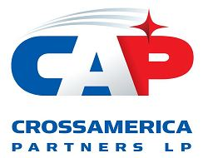
CrossAmerica Partners LP Reports First Quarter 2026 Results
-
Reported First Quarter of 2026 Net Income of $10.7 million, Adjusted EBITDA of $35.1 million and Distributable Cash Flow of $21.5 million compared to a Net Loss of $7.1 million, Adjusted EBITDA of $24.3 million and Distributable Cash Flow of $9.1 million for the First Quarter of 2025
-
Reported First Quarter of 2026 Gross Profit for the Retail Segment of $74.3 million compared to $63.2 million of Gross Profit for the First Quarter of 2025 and First Quarter of 2026 Gross Profit for the Wholesale Segment of $23.3 million compared to $26.7 million of Gross Profit for the First Quarter of 2025
-
Leverage, as defined in the CAPL Credit Facility, was 3.35 times as of March 31, 2026, compared to 4.27 times as of March 31, 2025
-
The Distribution Coverage Ratio for the trailing twelve months ended March 31, 2026 was 1.25 times compared to 1.04 times for the comparable period of 2025
-
The Board of Directors of CrossAmerica's General Partner declared a quarterly distribution of $0.5250 per limited partner unit attributable to the First Quarter of 2026
-
Appointed Maura Topper as Chief Executive Officer and President and Jon Benfield as Interim Chief Financial Officer effective March 2, 2026

Allentown, PA May 6, 2026 – CrossAmerica Partners LP (NYSE: CAPL) (“CrossAmerica” or the “Partnership”), a leading wholesale fuels distributor, convenience store operator, and owner and lessor of real estate used in the retail distribution of motor fuels, today reported financial results for the first quarter ended March 31, 2026.
"We started the new year with a strong first quarter generating a record level of Adjusted EBITDA for the Partnership, as our business benefited from the strategic initiatives we have been focused on for the last several years,” said Maura Topper, CEO and President of CrossAmerica. “Our increased exposure to retail operations drove strong motor fuel and merchandise gross profit performance, while our team's disciplined focus on cost management helped us deliver solid results across the business. The fuels market has experienced significant volatility over the past several weeks, and I'm proud of how our team has executed through it — our model and our people are well-suited to navigate this kind of environment. We also continued to pay down our credit facility during the quarter, improving our interest expense and leverage, and further strengthening our balance sheet as we look ahead to the remainder of 2026."

1

First Quarter Results
Consolidated Results
Key Operating Metrics | Q1 2026 | Q1 2025
Net Income (Loss) | $10.7M | ($7.1M)
Adjusted EBITDA | $35.1M | $24.3M
Distributable Cash Flow | $21.5M | $9.1M
Distribution Coverage Ratio: Current Quarter | 1.07x | 0.46x
Distribution Coverage Ratio: Trailing 12 Months | 1.25x | 1.04x

CrossAmerica reported increases in Net Income (Loss), Adjusted EBITDA, Distributable Cash Flow and Distribution Coverage for the first quarter of 2026 compared to the first quarter of 2025. The increase in Adjusted EBITDA was primarily driven by an increase in motor fuel margin per gallon and an increase in merchandise gross profit in the retail segment and an overall decline in operating and general and administrative expenses, partially offset by a decline in gross profit for the wholesale segment. The increase for the first quarter of 2026 in Net Income, Distributable Cash Flow and Distribution Coverage was primarily driven by the increase in Adjusted EBITDA noted above in addition to a $2.1 million decrease in interest expense due to a lower average interest rate along with a lower average outstanding debt balance.

Retail Segment
Key Operating Metrics | Q1 2026 | Q1 2025
Retail segment gross profit | $74.3M | $63.2M
Retail segment motor fuel gallons distributed | 117.7M | 126.5M
Same store motor fuel gallons distributed | 108.5M | 117.1M
Retail segment motor fuel gross profit | $39.9M | $31.2M
Retail segment margin per gallon, before deducting credit card fees and commissions | $0.437 | $0.339
Same store merchandise sales excluding cigarettes* | $59.6M | $58.3M
Merchandise gross profit* | $27.0M | $24.9M
Merchandise gross profit percentage* | 29.7% | 27.9%
Operating Expenses | $50.0M | $51.7M
Retail Sites (average for period) | 576 | 599
*Includes only company operated retail sites

For the first quarter of 2026, the retail segment generated an 18% increase in gross profit compared to the first quarter of 2025, primarily due to increases in both motor fuel and merchandise gross profit compared to the prior year.

The motor fuel gross profit for the retail segment increased $8.7 million or 28%, attributable to a 29% increase in the margin per gallon for the three months ended March 31, 2026 as compared to the same period in 2025. The increase in margin per gallon was primarily driven by movements in crude oil prices within the two periods and overall market volatility. The margin per gallon increase was partially offset by a motor fuel volume decrease of 7% driven by a 4% decrease in the average retail site count due to CrossAmerica's ongoing portfolio optimization efforts, as well as a decline in volume for the base business. Same store retail segment fuel volume for the first quarter of 2026 declined 7% from the first quarter of 2025.

2

For the first quarter of 2026, CrossAmerica’s merchandise gross profit increased 8% when compared to the first quarter of 2025. The first quarter increase was primarily driven by an increase in sales in the base business as well as an increase in the merchandise gross profit percentage. Same store merchandise sales excluding cigarettes increased 2% for the first quarter of 2026 when compared to the first quarter of 2025. Merchandise gross profit percentage increased from 27.9% for the first quarter of 2025 to 29.7% for the first quarter of 2026.

Operating expenses for the retail segment declined $1.7 million dollars or 3% with same store operating expenses also declining for the first quarter of 2026 when compared to the same period in 2025. In addition, the average retail segment site count decreased 4% relative to the prior year due to CrossAmerica's ongoing portfolio optimization efforts.

Wholesale Segment
Key Operating Metrics | Q1 2026 | Q1 2025
Wholesale segment gross profit | $23.3M | $26.7M
Wholesale motor fuel gallons distributed | 153.6M | 162.9M
Average wholesale gross profit per gallon | $0.094 | $0.097

During the first quarter of 2026, CrossAmerica’s wholesale segment gross profit decreased $3.3 million or 13% compared to the first quarter of 2025. The decline was primarily driven by a 20% or $1.9 million decrease in rent gross profit, primarily due to the sale of locations and conversions to retail operations as part of the Partnership’s portfolio optimization efforts. Motor fuel gross profit decreased 8% for the first quarter of 2026 when compared to the first quarter of 2025. The decline was driven by a 3% decrease in fuel margin per gallon and a 6% decline in wholesale volume distributed, primarily due to the loss of independent dealer contracts as well as the conversion of locations to the retail segment. Operating expenses declined $0.7 million or 10% due to the factors noted above.

Real Estate Activity

During the three months ended March 31, 2026, CrossAmerica sold 16 sites for $12.7 million in proceeds, resulting in a net gain of $6.3 million. CrossAmerica maintained a supply relationship post sale with substantially all of the locations divested during the quarter.

In May 2012, CrossAmerica’s predecessor entered into a 15-year master lease agreement with Getty. On January 31, 2026, CrossAmerica entered into an amendment of this lease that reset the rents for all 106 sites covered by this lease to an aggregate $6.9 million in annual rent, subject to annual escalations of 1.5%. This amendment also triggered a reassessment of lease accounting. Effective January 31, 2026, CrossAmerica is accounting for the modified lease fully as a finance lease, and as such, the finance lease obligations increased $56 million during the first quarter of 2026. The prior lease accounting resulted in approximately $3 million of the rent payments being accounted for as rent expense that will now be accounted for as principal and interest.

Liquidity and Capital Resources

As of March 31, 2026, CrossAmerica had $682.0 million outstanding under its Credit Facility. As of May 1, 2026, after taking into consideration debt covenant restrictions, approximately $230 million was available for future borrowings under the Credit Facility. Leverage, as defined in the Credit Facility, was 3.35 times as of March 31, 2026, compared to 4.27 times as of March 31, 2025. As of March 31, 2026, CrossAmerica was in compliance with its financial covenants under the credit facility.
3

Distributions

On April 22, 2026, the Board of the Directors of CrossAmerica’s General Partner (“Board”) declared a quarterly distribution of $0.5250 per limited partner unit attributable to the first quarter of 2026. As previously announced, the distribution will be paid on May 14, 2026, to all unitholders of record as of May 4, 2026. The amount and timing of any future distributions is subject to the discretion of the Board as provided in CrossAmerica’s Partnership Agreement.

Conference Call

The Partnership will host a conference call on May 7, 2026, at 9:00 a.m. Eastern Time to discuss the first quarter of 2026 earnings results. The conference call numbers are 800-717-1738 or 646-307-1865 and the passcode for both is 292954. A live audio webcast of the conference call and the related earnings materials, including reconciliations of any non-GAAP financial measures to GAAP financial measures and any other applicable disclosures, will be available on that same day on the investor section of the CrossAmerica website (www.crossamericapartners.com). After the live conference call, an archive of the webcast will be available on the investor section of the CrossAmerica site at https://caplp.gcs-web.com/webcasts-presentations within 24 hours after the call for a period of sixty days.

Non-GAAP Measures and Same Store Metrics

Non-GAAP measures used in this release include EBITDA, Adjusted EBITDA, Distributable Cash Flow and Distribution Coverage Ratio. These Non-GAAP measures are further described and reconciled to their most directly comparable GAAP measures in the Supplemental Disclosure Regarding Non-GAAP Financial Measures section of this release.

Same store fuel volume and same store merchandise sales include aggregated individual store results for all stores that had fuel volume or merchandise sales in all months for both periods within the same segment. Same store merchandise sales excludes other revenues such as lottery commissions and car wash sales.

4

CROSSAMERICA PARTNERS LP
CONSOLIDATED BALANCE SHEETS
(Thousands of Dollars, except unit data)
(Unaudited)

 |  | March 31, |  |  |  | December 31,
 |  | 2026 |  |  |  | 2025
ASSETS
Current assets:
Cash and cash equivalents |  | $ | 7,349 |  |  | $ | 3,137
Accounts receivable, net of allowances of $656 and $635, respectively |  |  | 31,139 |  |  |  | 28,566
Accounts receivable from related parties |  |  | 805 |  |  |  | 687
Inventory |  |  | 65,063 |  |  |  | 59,610
Assets held for sale |  |  | 7,732 |  |  |  | 9,690
Current portion of interest rate swap contracts |  |  | 1,497 |  |  |  | 801
Other current assets |  |  | 11,683 |  |  |  | 8,590
Total current assets |  |  | 125,268 |  |  |  | 111,081
Property and equipment, net |  |  | 589,385 |  |  |  | 547,686
Right-of-use assets, net |  |  | 107,622 |  |  |  | 121,636
Intangible assets, net |  |  | 57,988 |  |  |  | 61,638
Goodwill |  |  | 99,409 |  |  |  | 99,409
Deferred tax assets |  |  | 555 |  |  |  | 760
Interest rate swap contracts, less current portion |  |  | 1,082 |  |  |  | 325
Other assets |  |  | 21,490 |  |  |  | 22,199
Total assets |  | $ | 1,002,799 |  |  | $ | 964,734
LIABILITIES AND EQUITY
Current liabilities:
Current portion of debt and finance lease obligations |  | $ | 9,811 |  |  | $ | 3,465
Current portion of operating lease obligations |  |  | 25,325 |  |  |  | 29,008
Accounts payable |  |  | 77,404 |  |  |  | 63,413
Accounts payable to related parties |  |  | 7,189 |  |  |  | 6,536
Current portion of interest rate swap contracts |  |  | 431 |  |  |  | 697
Accrued expenses and other current liabilities |  |  | 28,596 |  |  |  | 27,378
Motor fuel and sales taxes payable |  |  | 19,151 |  |  |  | 19,013
Total current liabilities |  |  | 167,907 |  |  |  | 149,510
Debt and finance lease obligations, less current portion |  |  | 726,197 |  |  |  | 687,187
Operating lease obligations, less current portion |  |  | 86,148 |  |  |  | 96,974
Deferred tax liabilities, net |  |  | 7,193 |  |  |  | 7,409
Asset retirement obligations |  |  | 44,645 |  |  |  | 45,014
Interest rate swap contracts, less current portion |  |  | 517 |  |  |  | 1,390
Other long-term liabilities |  |  | 48,642 |  |  |  | 49,289
Total liabilities |  |  | 1,081,249 |  |  |  | 1,036,773
Commitments and contingencies (Note 9)
Preferred membership interests |  |  | 30,984 |  |  |  | 30,289
Equity:
Common units— 38,154,331 and 38,135,078 units issued and  outstanding at March 31, 2026 and December 31, 2025, respectively |  |  | (111,005 | ) |  |  | (101,280 | )
Accumulated other comprehensive income (loss) |  |  | 1,571 |  |  |  | (1,048 | )
Total deficit |  |  | (109,434 | ) |  |  | (102,328 | )
Total liabilities and equity |  | $ | 1,002,799 |  |  | $ | 964,734
5

CROSSAMERICA PARTNERS LP
CONSOLIDATED STATEMENTS OF OPERATIONS
(Thousands of Dollars, Except Unit and Per Unit Amounts)
(Unaudited)
 |  | Three Months Ended March 31,
 |  | 2026 |  |  |  | 2025
Operating revenues (a) |  | $ | 841,830 |  |  | $ | 862,475
Cost of sales (b) |  |  | 744,207 |  |  |  | 772,661
Gross profit |  |  | 97,623 |  |  |  | 89,814
Operating expenses:
Operating expenses (c) |  |  | 56,436 |  |  |  | 58,874
General and administrative expenses |  |  | 6,491 |  |  |  | 7,672
Depreciation, amortization and accretion expense |  |  | 17,062 |  |  |  | 26,304
Total operating expenses |  |  | 79,989 |  |  |  | 92,850
Gain on dispositions and lease terminations, net |  |  | 6,116 |  |  |  | 5,037
Operating income |  |  | 23,750 |  |  |  | 2,001
Other income, net |  |  | 157 |  |  |  | 130
Interest expense |  |  | (10,750 | ) |  |  | (12,844 | )
Income (loss) before income taxes |  |  | 13,157 |  |  |  | (10,713 | )
Income tax expense (benefit) |  |  | 2,498 |  |  |  | (3,598 | )
Net income (loss) |  |  | 10,659 |  |  |  | (7,115 | )
Accretion of preferred membership interests |  |  | 694 |  |  |  | 665
Net income (loss) available to limited partners |  | $ | 9,965 |  |  | $ | (7,780 | )
Net income (loss) per common unit
Basic |  | $ | 0.26 |  |  | $ | (0.20 | )
Diluted |  | $ | 0.26 |  |  | $ | (0.20 | )
Weighted-average common units:
Basic |  |  | 38,142,565 |  |  |  | 38,073,986
Diluted |  |  | 38,301,882 |  |  |  | 38,073,986
Supplemental information:
(a) includes excise taxes of: |  | $ | 68,770 |  |  | $ | 73,350
(a) includes rent income of: |  |  | 14,560 |  |  |  | 17,202
(b) excludes depreciation, amortization and accretion
(b) includes rent expense of: |  |  | 4,117 |  |  |  | 4,895
(c) includes rent expense of: |  |  | 4,559 |  |  |  | 4,611

6

CROSSAMERICA PARTNERS LP
CONSOLIDATED STATEMENTS OF CASH FLOWS
(Thousands of Dollars)
(Unaudited)

 |  | Three Months Ended March 31,
 |  | 2026 |  |  |  | 2025
Cash flows from operating activities:
Net income (loss) |  | $ | 10,659 |  |  | $ | (7,115 | )
Adjustments to reconcile net income (loss) to net cash provided by operating activities:
Depreciation, amortization and accretion expense |  |  | 17,062 |  |  |  | 26,304
Amortization of deferred financing costs |  |  | 484 |  |  |  | 485
Credit loss expense |  |  | 24 |  |  |  | —
Deferred income tax benefit |  |  | (11 | ) |  |  | (3,692 | )
Equity-based employee and director compensation expense |  |  | 201 |  |  |  | 813
Gain on dispositions and lease terminations, net |  |  | (6,116 | ) |  |  | (5,037 | )
Changes in operating assets and liabilities, net of acquisitions |  |  | 5,574 |  |  |  | 3,289
Net cash provided by operating activities |  |  | 27,877 |  |  |  | 15,047
Cash flows from investing activities:
Principal payments received on notes receivable |  |  | 23 |  |  |  | 34
Proceeds from sale of assets |  |  | 13,045 |  |  |  | 8,745
Capital expenditures |  |  | (3,425 | ) |  |  | (10,114 | )
Cash paid in connection with acquisitions, net of cash acquired |  |  | (1,800 | ) |  |  | —
Net cash provided by (used in) investing activities |  |  | 7,843 |  |  |  | (1,335 | )
Cash flows from financing activities:
Borrowings under the Credit Facility |  |  | 24,705 |  |  |  | 29,000
Repayments on the Credit Facility |  |  | (35,000 | ) |  |  | (18,500 | )
Payments of finance lease obligations |  |  | (1,123 | ) |  |  | (791 | )
Distributions paid on distribution equivalent rights |  |  | (69 | ) |  |  | (73 | )
Distributions paid on common units |  |  | (20,021 | ) |  |  | (19,981 | )
Net cash used in financing activities |  |  | (31,508 | ) |  |  | (10,345 | )
Net increase in cash and cash equivalents |  |  | 4,212 |  |  |  | 3,367
Cash and cash equivalents at beginning of period |  |  | 3,137 |  |  |  | 3,381
Cash and cash equivalents at end of period |  | $ | 7,349 |  |  | $ | 6,748

7

Segment Results
Retail
The following table highlights the results of operations and certain operating metrics of the Retail segment (in thousands, except for the number of retail sites and per gallon amounts):
 |  | Three Months Ended March 31,
 |  | 2026 |  |  |  | 2025
Gross profit:
Motor fuel |  | $ | 39,860 |  |  | $ | 31,180
Merchandise |  |  | 26,952 |  |  |  | 24,913
Rent |  |  | 2,682 |  |  |  | 2,611
Other revenue |  |  | 4,809 |  |  |  | 4,455
Total gross profit |  |  | 74,303 |  |  |  | 63,159
Operating expenses |  |  | (49,999 | ) |  |  | (51,704 | )
Operating income |  | $ | 24,304 |  |  | $ | 11,455
Retail sites (end of period):
Company operated retail sites (a) |  |  | 340 |  |  |  | 376
Commission agents (b) |  |  | 228 |  |  |  | 234
Total retail sites |  |  | 568 |  |  |  | 610
Total retail segment statistics:
Volume of gallons sold |  |  | 117,686 |  |  |  | 126,532
Same store total system gallons sold(c) |  |  | 108,477 |  |  |  | 117,089
Average retail fuel sites |  |  | 576 |  |  |  | 599
Margin per gallon, before deducting credit card fees and commissions |  | $ | 0.437 |  |  | $ | 0.339
Company operated site statistics:
Average retail fuel sites |  |  | 345 |  |  |  | 368
Same store fuel volume(c) |  |  | 76,936 |  |  |  | 80,349
Margin per gallon, before deducting credit card fees |  | $ | 0.458 |  |  | $ | 0.374
Same store merchandise sales(c) |  | $ | 83,252 |  |  | $ | 81,842
Same store merchandise sales excluding cigarettes(c) |  | $ | 59,622 |  |  | $ | 58,307
Merchandise gross profit percentage |  |  | 29.7 | % |  |  | 27.9 | %
Commission site statistics:
Average retail fuel sites |  |  | 231 |  |  |  | 231
Margin per gallon, before deducting credit card fees and commissions |  | $ | 0.385 |  |  | $ | 0.263

(a) The decrease in the company operated site count was primarily attributable to the sale of certain company operated sites in connection with CrossAmerica's real estate rationalization effort, partially offset by the conversion of certain lessee dealer sites to company operated sites.
(b) The decrease in the commission agent site count was primarily attributable to the sale of certain commission agent sites in connection with CrossAmerica's real estate rationalization effort, partially offset by the conversion of certain lessee dealer sites to commission agent sites.
(c) Same store fuel volume and same store merchandise sales include aggregated individual store results for all stores that had fuel volume or merchandise sales in all months for both periods. Same store merchandise sales excludes other revenues such as lottery commissions and car wash sales.

8

Wholesale

The following table highlights the results of operations and certain operating metrics of the Wholesale segment (thousands of dollars, except for the number of distribution sites and per gallon amounts):
 |  | Three Months Ended March 31,
 |  | 2026 |  |  |  | 2025
Gross profit:
Motor fuel gross profit |  | $ | 14,453 |  |  | $ | 15,764
Rent gross profit |  |  | 7,761 |  |  |  | 9,696
Other revenues |  |  | 1,106 |  |  |  | 1,195
Total gross profit |  |  | 23,320 |  |  |  | 26,655
Operating expenses |  |  | (6,437 | ) |  |  | (7,170 | )
Operating income |  | $ | 16,883 |  |  | $ | 19,485
Motor fuel distribution sites (end of period): (a)
Independent dealers (b) |  |  | 666 |  |  |  | 604
Lessee dealers (c) |  |  | 319 |  |  |  | 412
Total motor fuel distribution sites |  |  | 985 |  |  |  | 1,016
Average motor fuel distribution sites |  |  | 987 |  |  |  | 1,031
Volume of gallons distributed |  |  | 153,588 |  |  |  | 162,918
Margin per gallon |  | $ | 0.094 |  |  | $ | 0.097

(a) In addition, CrossAmerica distributed motor fuel to sub-wholesalers who distributed to additional sites.
(b) The increase in the independent dealer site count was primarily attributable to the sale of certain lessee dealer, company operated and commission agent sites but with continued fuel supply, partially offset by the net loss of independent dealer contracts.
(c) The decrease in the lessee dealer count was primarily attributable to the sale of certain lessee dealer sites in connection with CrossAmerica's real estate rationalization effort (generally with continued fuel supply, thereby converting the site to an independent dealer site) as well as the conversion of certain lessee dealer sites to company operated and commission agent sites.

9

Supplemental Disclosure Regarding Non-GAAP Financial Measures

CrossAmerica uses the non-GAAP financial measures EBITDA, Adjusted EBITDA, Distributable Cash Flow and Distribution Coverage Ratio. EBITDA represents net income (loss) before deducting interest expense, income taxes and depreciation, amortization and accretion (which includes certain impairment charges). Adjusted EBITDA represents EBITDA as further adjusted to exclude equity-based compensation expense, gains or losses on dispositions and lease terminations, net and certain discrete acquisition related costs, such as legal and other professional fees, separation benefit costs and certain other discrete non-cash items arising from purchase accounting. Distributable Cash Flow represents Adjusted EBITDA less cash interest expense, sustaining capital expenditures and current income tax expense. The Distribution Coverage Ratio is computed by dividing Distributable Cash Flow by distributions paid on common units.

EBITDA, Adjusted EBITDA, Distributable Cash Flow and Distribution Coverage Ratio are used as supplemental financial measures by management and by external users of our financial statements, such as investors and lenders. EBITDA and Adjusted EBITDA are used to assess CrossAmerica’s financial performance without regard to financing methods, capital structure or income taxes and the ability to incur and service debt and to fund capital expenditures. In addition, Adjusted EBITDA is used to assess the operating performance of the Partnership’s business on a consistent basis by excluding the impact of items which do not result directly from the wholesale distribution of motor fuel, the leasing of real property, or the day to day operations of CrossAmerica’s retail site activities. EBITDA, Adjusted EBITDA, Distributable Cash Flow and Distribution Coverage Ratio are also used to assess the ability to generate cash sufficient to make distributions to CrossAmerica’s unitholders.

CrossAmerica believes the presentation of EBITDA, Adjusted EBITDA, Distributable Cash Flow and Distribution Coverage Ratio provides useful information to investors in assessing the financial condition and results of operations. EBITDA, Adjusted EBITDA, Distributable Cash Flow and Distribution Coverage Ratio should not be considered alternatives to net income or any other measure of financial performance or liquidity presented in accordance with U.S. GAAP. EBITDA, Adjusted EBITDA, Distributable Cash Flow and Distribution Coverage Ratio have important limitations as analytical tools because they exclude some but not all items that affect net income. Additionally, because EBITDA, Adjusted EBITDA, Distributable Cash Flow and Distribution Coverage Ratio may be defined differently by other companies in the industry, CrossAmerica’s definitions may not be comparable to similarly titled measures of other companies, thereby diminishing their utility.

The following table presents reconciliations of EBITDA, Adjusted EBITDA, and Distributable Cash Flow to net income (loss), the most directly comparable U.S. GAAP financial measure, for each of the periods indicated (in thousands, except for Distribution Coverage Ratio):

 |  | Three Months Ended March 31,
 |  | 2026 |  |  |  | 2025
Net income (loss) |  | $ | 10,659 |  |  | $ | (7,115 | )
Interest expense |  |  | 10,750 |  |  |  | 12,844
Income tax expense (benefit) |  |  | 2,498 |  |  |  | (3,598 | )
Depreciation, amortization and accretion expense |  |  | 17,062 |  |  |  | 26,304
EBITDA |  |  | 40,969 |  |  |  | 28,435
Equity-based employee and director compensation expense |  |  | 201 |  |  |  | 813
Gain on dispositions and lease terminations, net (a) |  |  | (6,116 | ) |  |  | (5,037 | )
Acquisition-related costs (b) |  |  | 27 |  |  |  | 58
Adjusted EBITDA |  |  | 35,081 |  |  |  | 24,269
Cash interest expense |  |  | (10,265 | ) |  |  | (12,359 | )
Sustaining capital expenditures (c) |  |  | (1,350 | ) |  |  | (2,721 | )
Current income tax expense (d) |  |  | (1,964 | ) |  |  | (94 | )
Distributable Cash Flow |  | $ | 21,502 |  |  | $ | 9,095
Distributions paid on common units |  |  | 20,021 |  |  |  | 19,981
Distribution Coverage Ratio |  | 1.07x |  |  |  | 0.46x

10

(a) Primarily includes net gains in connection with CrossAmerica's ongoing real estate rationalization effort of $6.3 million and $5.6 million for the three months ended March 31, 2026 and 2025, respectively.
(b) Relates to certain acquisition-related costs, such as legal and other professional fees, separation benefit costs and purchase accounting adjustments associated with recent acquisitions.
(c) Under the Partnership Agreement, sustaining capital expenditures are capital expenditures made to maintain CrossAmerica's long-term operating income or operating capacity. Examples of sustaining capital expenditures are those made to maintain existing contract volumes or to maintain the sites in conditions suitable to operate or lease, such as parking lot or roof replacement/renovation, or to replace equipment required to operate the existing business.
(d) Excludes $0.5 million of current income tax incurred on sales of sites for the first quarter of 2026.

About CrossAmerica Partners LP
CrossAmerica Partners LP is a leading wholesale distributor of motor fuels, convenience store operator, and owner and lessee of real estate used in the retail distribution of motor fuels. Its general partner, CrossAmerica GP LLC, is indirectly owned and controlled by entities affiliated with Joseph V. Topper, Jr., the founder of CrossAmerica Partners and a member of the board of the general partner since 2012. Formed in 2012, CrossAmerica Partners LP is a distributor of branded and unbranded petroleum for motor vehicles in the United States and distributes fuel to approximately 1,600 locations and owns or leases approximately 900 sites. With a geographic footprint covering 34 states, the Partnership has well-established relationships with several major oil brands, including ExxonMobil, BP, Shell, Marathon, Valero, Phillips 66 and other major brands. CrossAmerica Partners LP ranks as one of ExxonMobil’s largest distributors by fuel volume in the United States and in the top 10 for additional brands. For additional information, please visit www.crossamericapartners.com.
Contact
Investor Relations: Randy Palmer, rpalmer@caplp.com or 610-625-8000
Cautionary Statement Regarding Forward-Looking Statements
Statements contained in this release that state the Partnership’s or management’s expectations or predictions of the future are forward-looking statements. The words “believe,” “expect,” “should,” “intends,” “estimates,” “target” and other similar expressions identify forward-looking statements. It is important to note that actual results could differ materially from those projected in such forward-looking statements. For more information concerning factors that could cause actual results to differ from those expressed or forecasted, see CrossAmerica’s Form 10-K or Forms 10-Q filed with the Securities and Exchange Commission, and available on CrossAmerica’s website at www.crossamericapartners.com. The Partnership undertakes no obligation to publicly update or revise any statements in this release, whether as a result of new information, future events or otherwise.

11

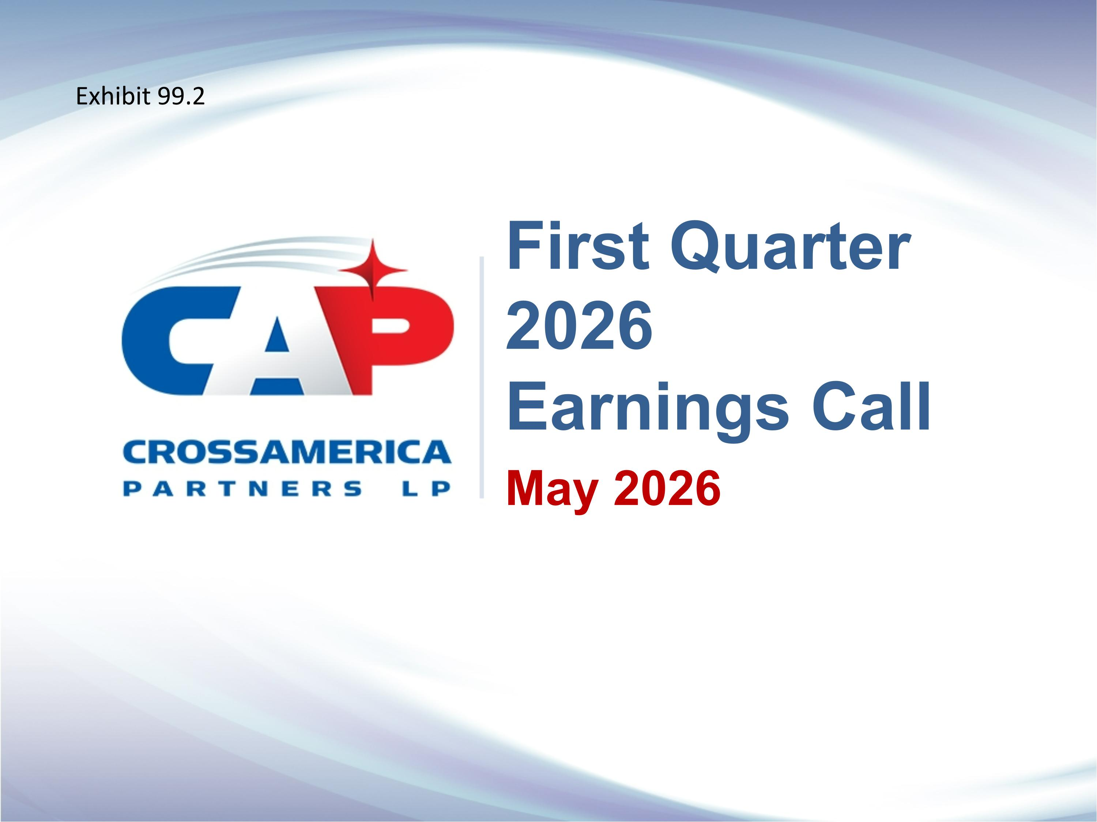
May 2026 First Quarter 2026 ?Earnings Call Exhibit 99.2

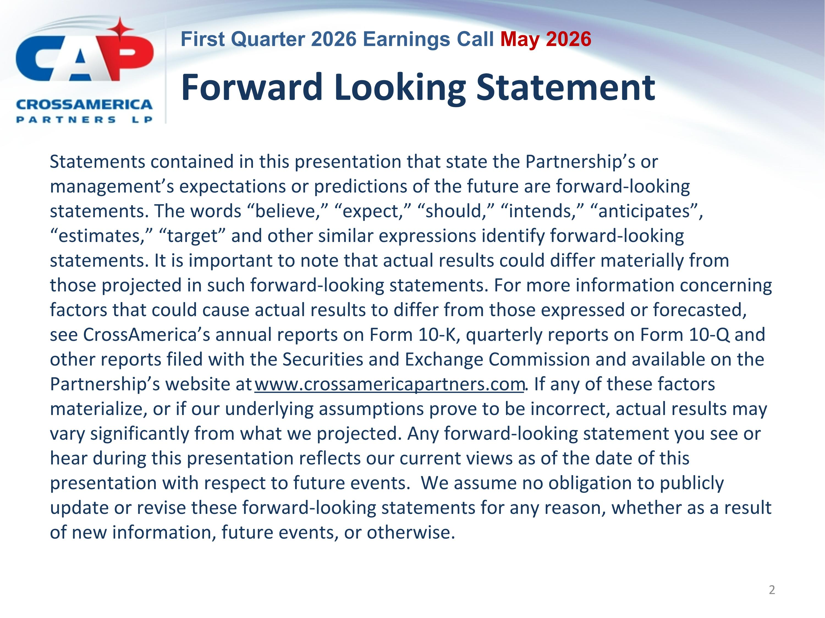
Forward Looking Statement Statements contained in this presentation that state the Partnership’s or management’s expectations or predictions of the future are forward-looking statements. The words “believe,” “expect,” “should,” “intends,” “anticipates”, “estimates,” “target” and other similar expressions identify forward-looking statements. It is important to note that actual results could differ materially from those projected in such forward-looking statements. For more information concerning factors that could cause actual results to differ from those expressed or forecasted, see CrossAmerica’s annual reports on Form 10-K, quarterly reports on Form 10-Q and other reports filed with the Securities and Exchange Commission and available on the Partnership’s website at www.crossamericapartners.com. If any of these factors materialize, or if our underlying assumptions prove to be incorrect, actual results may vary significantly from what we projected. Any forward-looking statement you see or hear during this presentation reflects our current views as of the date of this presentation with respect to future events. We assume no obligation to publicly update or revise these forward-looking statements for any reason, whether as a result of new information, future events, or otherwise.

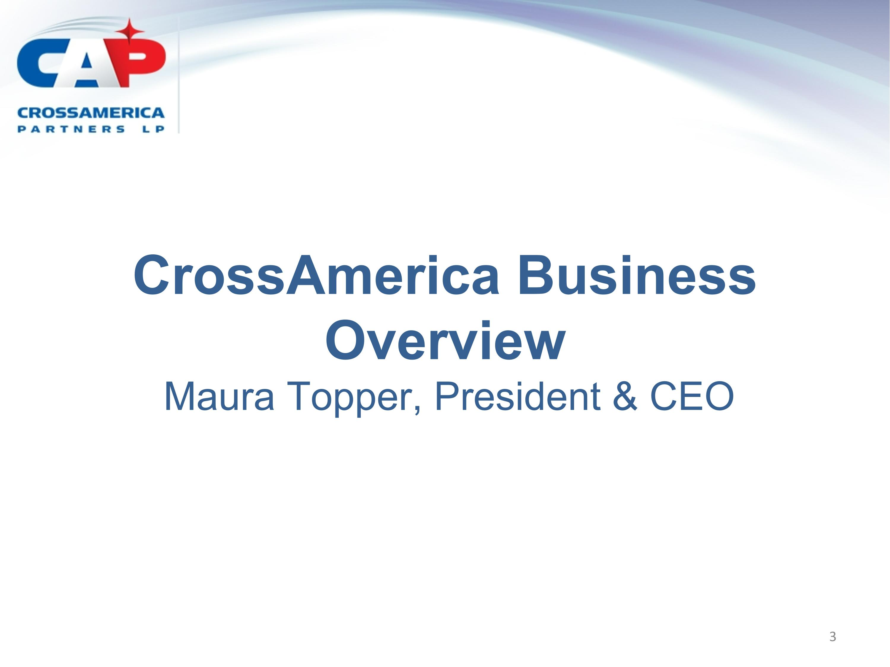
CrossAmerica Business Overview?Maura Topper, President & CEO

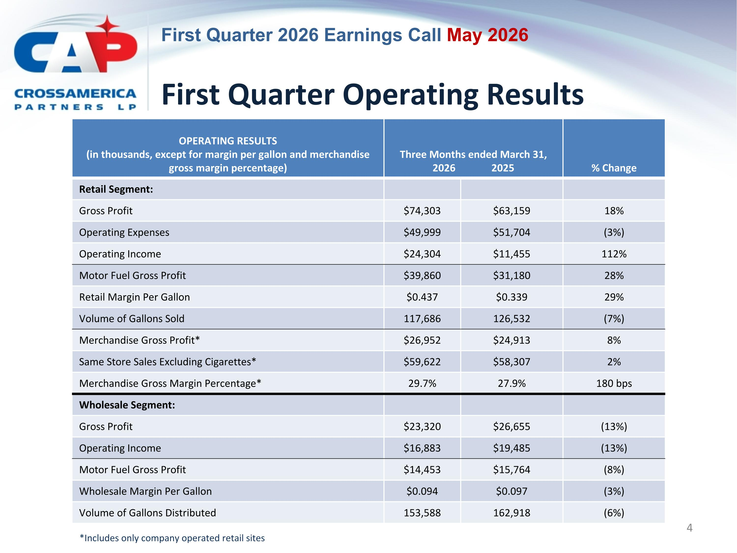
First Quarter Operating Results OPERATING RESULTS (in thousands, except for margin per gallon and merchandise gross margin percentage) Three Months ended March 31, 2026 2025 % Change Retail Segment: Gross Profit $74,303 $63,159 18% Operating Expenses $49,999 $51,704 (3%) Operating Income $24,304 $11,455 112% Motor Fuel Gross Profit $39,860 $31,180 28% Retail Margin Per Gallon $0.437 $0.339 29% Volume of Gallons Sold 117,686 126,532 (7%) Merchandise Gross Profit* $26,952 $24,913 8% Same Store Sales Excluding Cigarettes* $59,622 $58,307 2% Merchandise Gross Margin Percentage* 29.7% 27.9% 180 bps Wholesale Segment: Gross Profit $23,320 $26,655 (13%) Operating Income $16,883 $19,485 (13%) Motor Fuel Gross Profit $14,453 $15,764 (8%) Wholesale Margin Per Gallon $0.094 $0.097 (3%) Volume of Gallons Distributed 153,588 162,918 (6%) *Includes only company operated retail sites

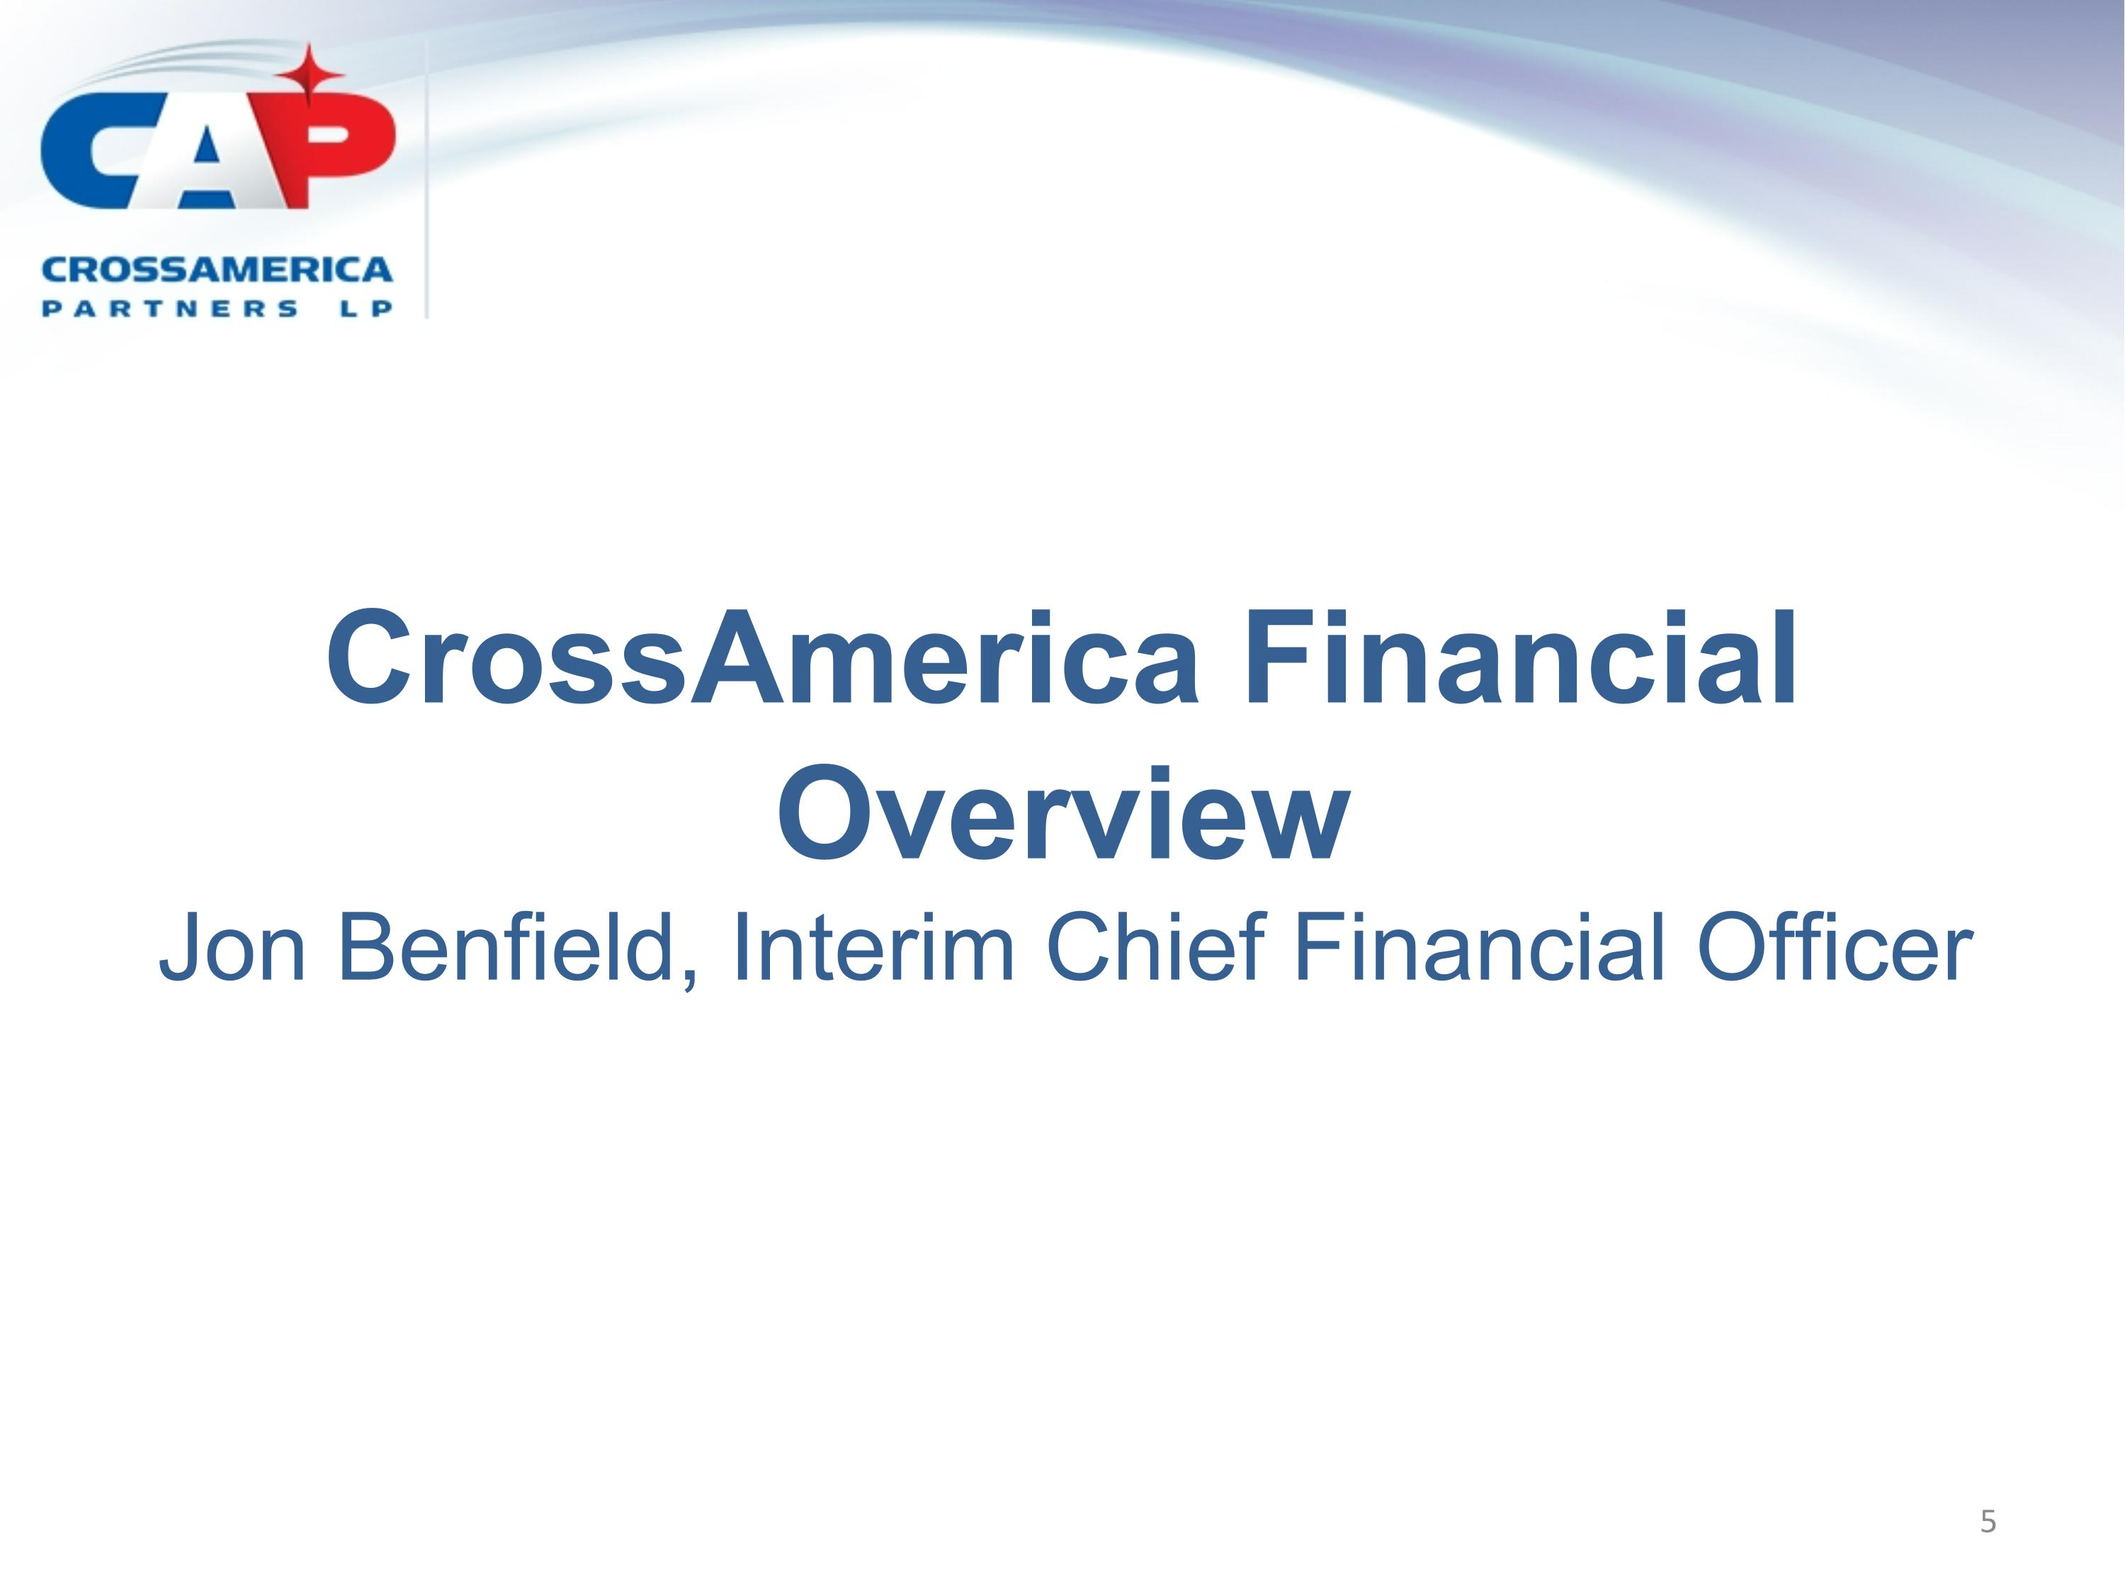
CrossAmerica Financial Overview?Jon Benfield, Interim Chief Financial Officer

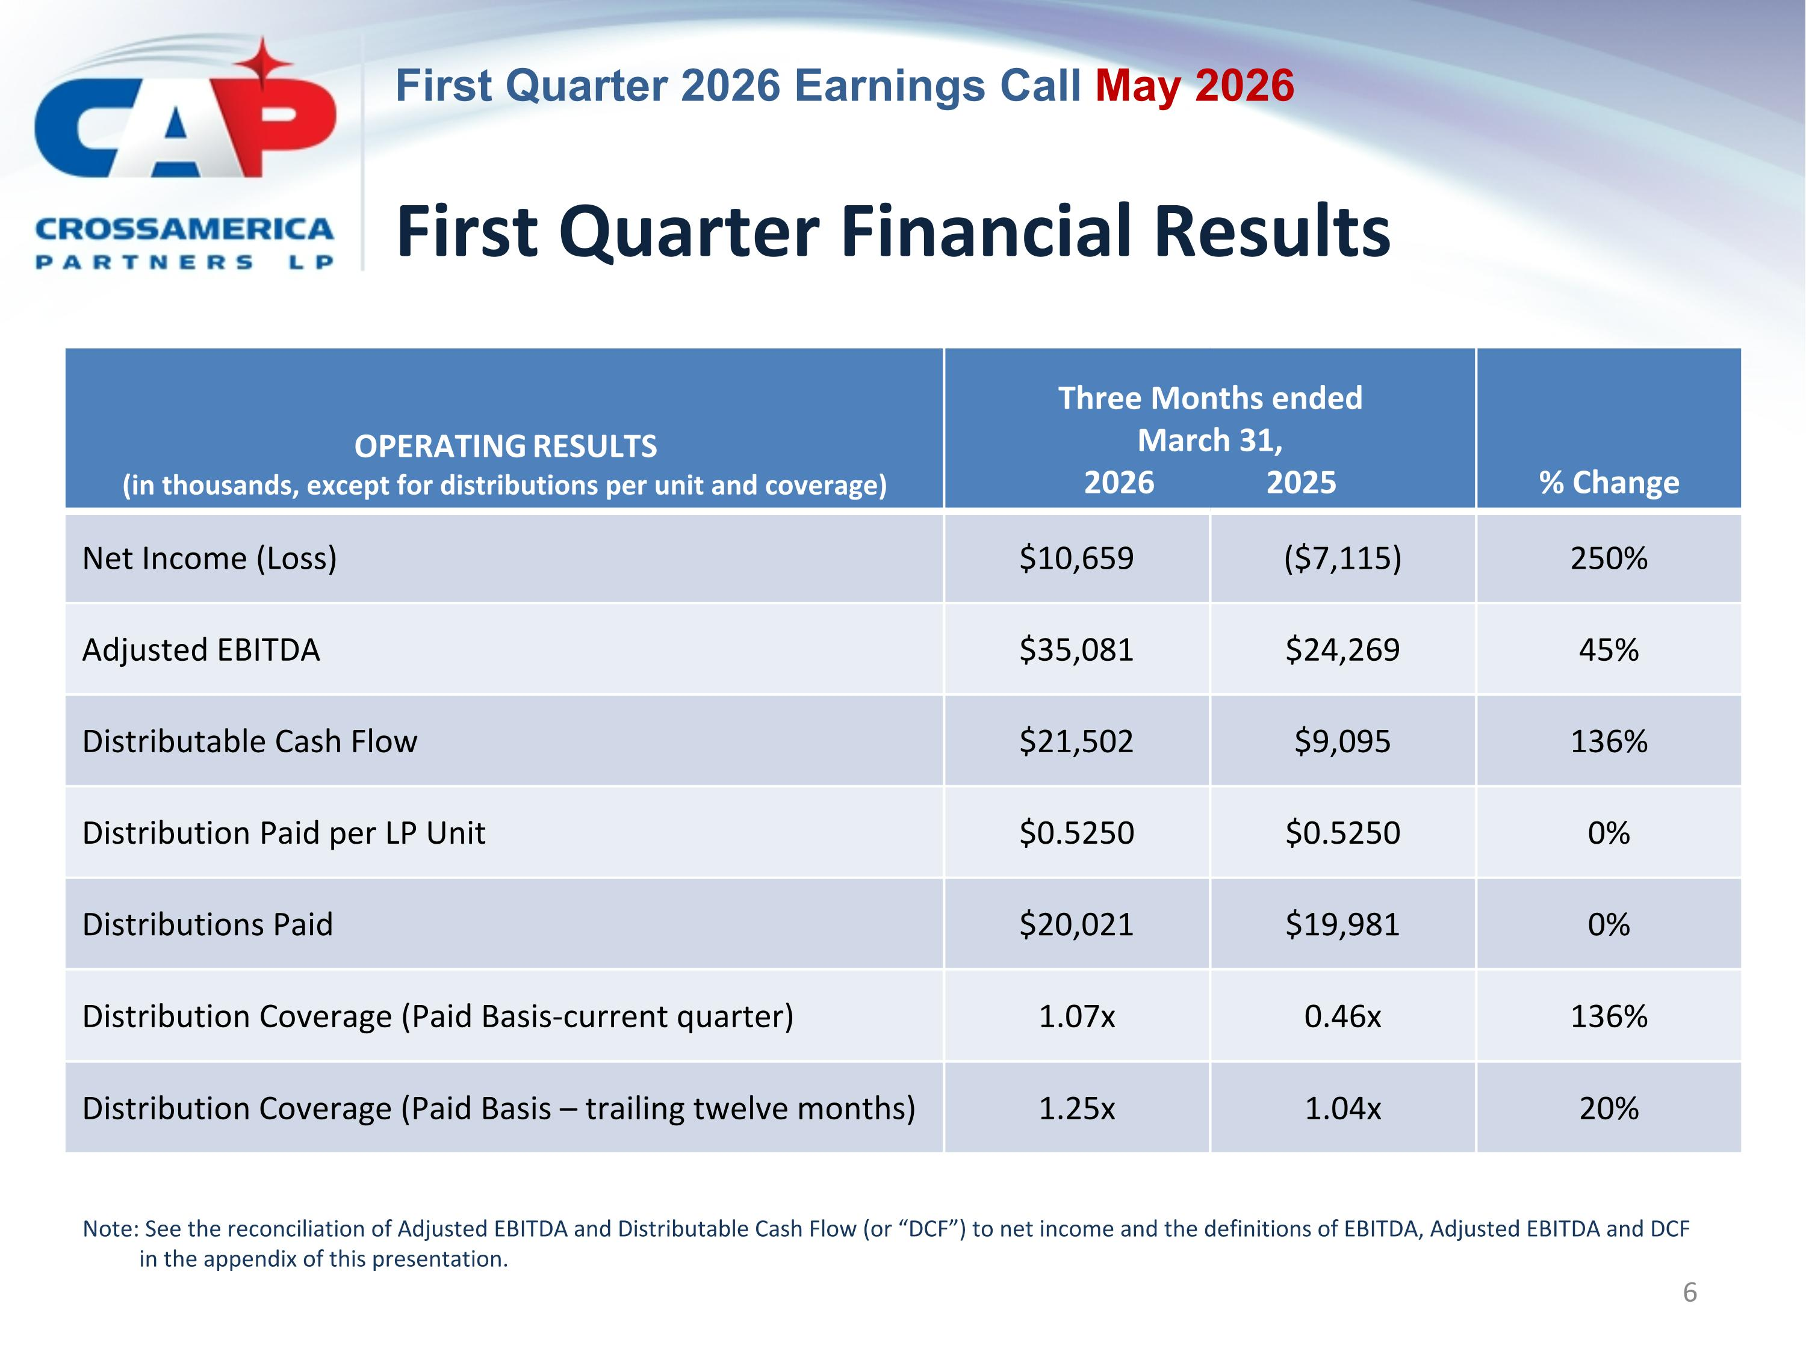
First Quarter Financial Results OPERATING RESULTS (in thousands, except for distributions per unit and coverage) Three Months ended March 31,?2026 2025 % Change Net Income (Loss) $10,659 ($7,115) 250% Adjusted EBITDA $35,081 $24,269 45% Distributable Cash Flow $21,502 $9,095 136% Distribution Paid per LP Unit $0.5250 $0.5250 0% Distributions Paid $20,021 $19,981 0% Distribution Coverage (Paid Basis-current quarter) 1.07x 0.46x 136% Distribution Coverage (Paid Basis – trailing twelve months) 1.25x 1.04x 20% Note: See the reconciliation of Adjusted EBITDA and Distributable Cash Flow (or “DCF”) to net income and the definitions of EBITDA, Adjusted EBITDA and DCF in the appendix of this presentation.

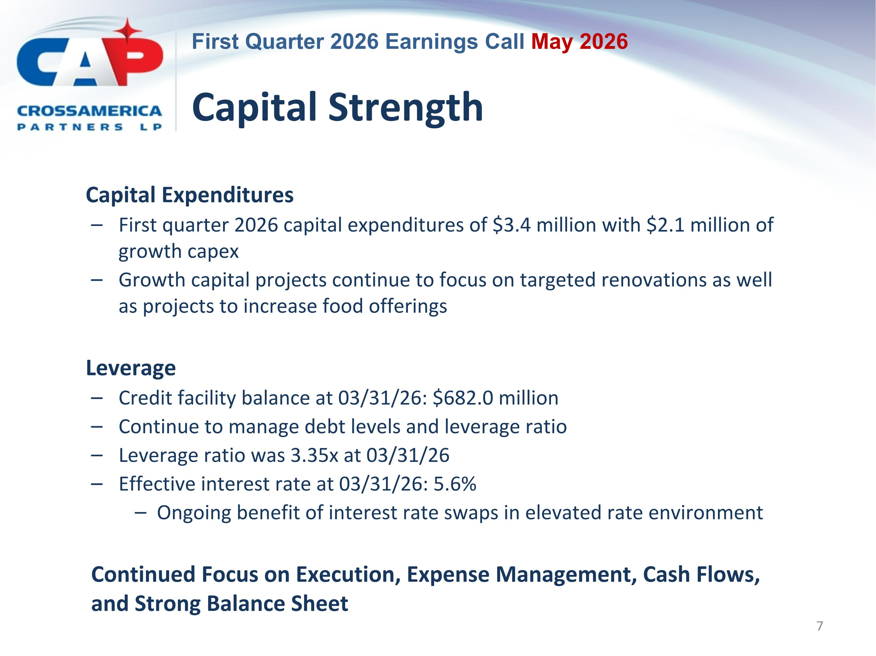
Capital Strength Capital Expenditures First quarter 2026 capital expenditures of $3.4 million with $2.1 million of growth capex Growth capital projects continue to focus on targeted renovations as well as projects to increase food offerings Leverage Credit facility balance at 03/31/26: $682.0 million Continue to manage debt levels and leverage ratio Leverage ratio was 3.35x at 03/31/26 Effective interest rate at 03/31/26: 5.6% Ongoing benefit of interest rate swaps in elevated rate environment Continued Focus on Execution, Expense Management, Cash Flows, and Strong Balance Sheet

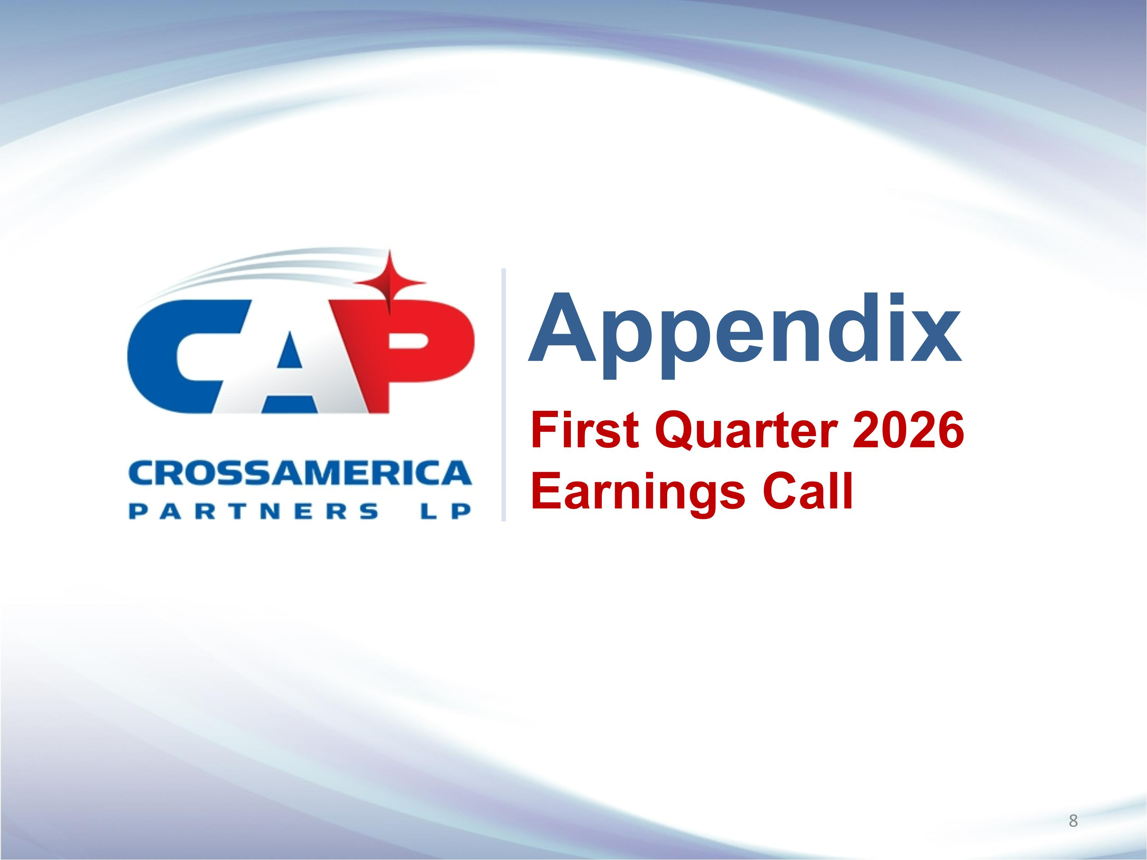
Appendix First Quarter 2026 Earnings Call

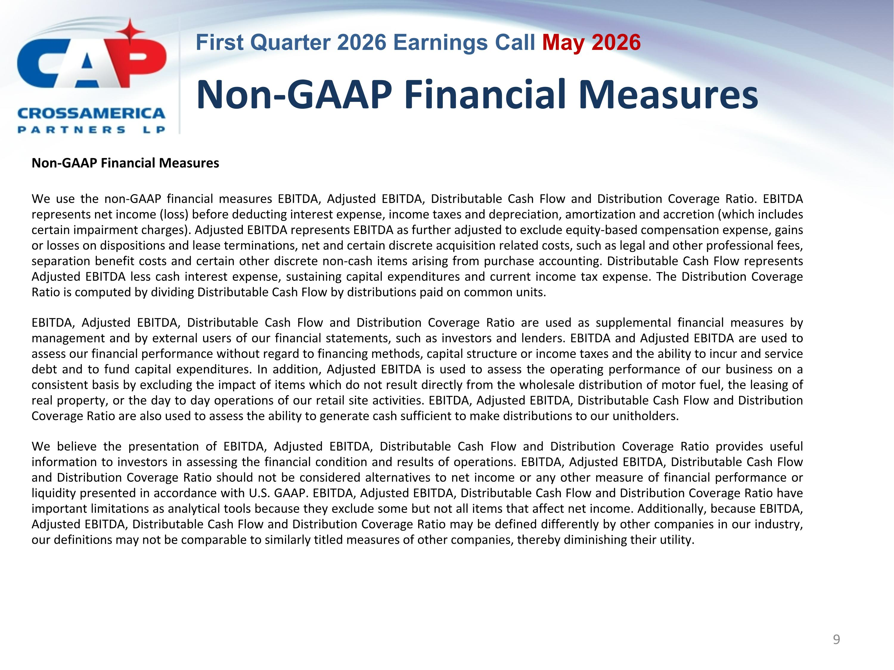
Non-GAAP Financial Measures Non-GAAP Financial Measures We use the non-GAAP financial measures EBITDA, Adjusted EBITDA, Distributable Cash Flow and Distribution Coverage Ratio. EBITDA represents net income (loss) before deducting interest expense, income taxes and depreciation, amortization and accretion (which includes certain impairment charges). Adjusted EBITDA represents EBITDA as further adjusted to exclude equity-based compensation expense, gains or losses on dispositions and lease terminations, net and certain discrete acquisition related costs, such as legal and other professional fees, separation benefit costs and certain other discrete non-cash items arising from purchase accounting. Distributable Cash Flow represents Adjusted EBITDA less cash interest expense, sustaining capital expenditures and current income tax expense. The Distribution Coverage Ratio is computed by dividing Distributable Cash Flow by distributions paid on common units. EBITDA, Adjusted EBITDA, Distributable Cash Flow and Distribution Coverage Ratio are used as supplemental financial measures by management and by external users of our financial statements, such as investors and lenders. EBITDA and Adjusted EBITDA are used to assess our financial performance without regard to financing methods, capital structure or income taxes and the ability to incur and service debt and to fund capital expenditures. In addition, Adjusted EBITDA is used to assess the operating performance of our business on a consistent basis by excluding the impact of items which do not result directly from the wholesale distribution of motor fuel, the leasing of real property, or the day to day operations of our retail site activities. EBITDA, Adjusted EBITDA, Distributable Cash Flow and Distribution Coverage Ratio are also used to assess the ability to generate cash sufficient to make distributions to our unitholders. We believe the presentation of EBITDA, Adjusted EBITDA, Distributable Cash Flow and Distribution Coverage Ratio provides useful information to investors in assessing the financial condition and results of operations. EBITDA, Adjusted EBITDA, Distributable Cash Flow and Distribution Coverage Ratio should not be considered alternatives to net income or any other measure of financial performance or liquidity presented in accordance with U.S. GAAP. EBITDA, Adjusted EBITDA, Distributable Cash Flow and Distribution Coverage Ratio have important limitations as analytical tools because they exclude some but not all items that affect net income. Additionally, because EBITDA, Adjusted EBITDA, Distributable Cash Flow and Distribution Coverage Ratio may be defined differently by other companies in our industry, our definitions may not be comparable to similarly titled measures of other companies, thereby diminishing their utility.

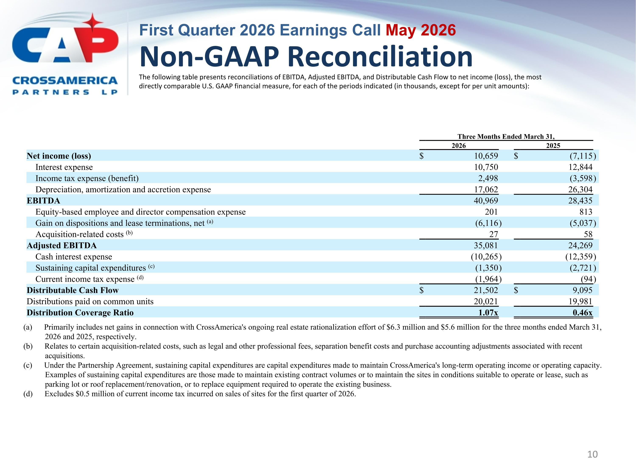
Non-GAAP Reconciliation The following table presents reconciliations of EBITDA, Adjusted EBITDA, and Distributable Cash Flow to net income (loss), the most directly comparable U.S. GAAP financial measure, for each of the periods indicated (in thousands, except for per unit amounts): (a) Primarily includes net gains in connection with CrossAmerica's ongoing real estate rationalization effort of $6.3 million and $5.6 million for the three months ended March 31, 2026 and 2025, respectively. (b) Relates to certain acquisition-related costs, such as legal and other professional fees, separation benefit costs and purchase accounting adjustments associated with recent acquisitions. (c) Under the Partnership Agreement, sustaining capital expenditures are capital expenditures made to maintain CrossAmerica's long-term operating income or operating capacity. Examples of sustaining capital expenditures are those made to maintain existing contract volumes or to maintain the sites in conditions suitable to operate or lease, such as parking lot or roof replacement/renovation, or to replace equipment required to operate the existing business. (d) Excludes $0.5 million of current income tax incurred on sales of sites for the first quarter of 2026. Three Months Ended March 31, 2026 2025 Net income (loss) $ 10,659 $ (7,115 ) Interest expense 10,750 12,844 Income tax expense (benefit) 2,498 (3,598 ) Depreciation, amortization and accretion expense 17,062 26,304 EBITDA 40,969 28,435 Equity-based employee and director compensation expense 201 813 Gain on dispositions and lease terminations, net (a) (6,116 ) (5,037 ) Acquisition-related costs (b) 27 58 Adjusted EBITDA 35,081 24,269 Cash interest expense (10,265 ) (12,359 ) Sustaining capital expenditures (c) (1,350 ) (2,721 ) Current income tax expense (d) (1,964 ) (94 ) Distributable Cash Flow $ 21,502 $ 9,095 Distributions paid on common units 20,021 19,981 Distribution Coverage Ratio 1.07x 0.46x

