UNITED STATES
SECURITIES AND EXCHANGE COMMISSION
Washington, D.C. 20549
FORM 8-K
CURRENT REPORT
Pursuant to Section 13 OR 15(d) of the Securities Exchange Act of 1934
Date of Report (Date of earliest event reported): August 5, 2026
CrossAmerica Partners LP
(Exact name of registrant as specified in its charter)

Delaware |  | 001-35711 |  | 45-4165414
(State or other jurisdiction  of incorporation) |  | (Commission File Number) |  | (IRS Employer  Identification No.)

645 Hamilton Street, Suite 400  Allentown, PA |  | 18101
(Address of principal executive offices) |  | (Zip Code)

Registrant’s telephone number, including area code: (610) 625-8000
Check the appropriate box below if the Form 8-K filing is intended to simultaneously satisfy the filing obligation of the registrant under any of the following provisions:
☐ | Written communications pursuant to Rule 425 under the Securities Act (17 CFR 230.425)
☐ | Soliciting material pursuant to Rule 14a-12 under the Exchange Act (17 CFR 240.14a-12)
☐ | Pre-commencement communications pursuant to Rule 14d-2(b) under the Exchange Act (17 CFR 240.14d-2(b))
☐ | Pre-commencement communications pursuant to Rule 13e-4(c) under the Exchange Act (17 CFR 240.13e-4(c))

Securities registered pursuant to Section 12(b) of the Act:

Title of each class | Trading Symbol(s) | Name of each exchange on which registered
Common Units | CAPL | New York Stock Exchange
Indicate by check mark whether the registrant is an emerging growth company as defined in Rule 405 of the Securities Act of 1933 (§230.405 of this chapter) or Rule 12b-2 of the Securities Exchange Act of 1934 (§240.12b-2 of this chapter).
Emerging growth company ☐
If an emerging growth company, indicate by check mark if the registrant has elected not to use the extended transition period for complying with any new or revised financial accounting standards provided pursuant to Section 13(a) of the Exchange Act. ☐

Item 2.02 Results of Operations and Financial Condition.
On August 5, 2026, CrossAmerica Partners LP (“CrossAmerica” or the “Partnership”) issued a press release announcing its financial results for the quarter ended June 30, 2026. A copy of the press release is furnished as Exhibit 99.1 to this Current Report on Form 8-K.
Item 7.01 Regulation FD Disclosure.
Furnished herewith as Exhibit 99.2 are slides that senior management of CrossAmerica will utilize in CrossAmerica’s second quarter 2026 earnings call. The slides are available on the Webcasts & Presentations page of CrossAmerica’s website at www.crossamericapartners.com.
The information in Item 2.02, Item 7.01 and Exhibits 99.1 and 99.2 of Item 9.01 of this report, according to general instruction B.2., shall not be deemed “filed” for the purposes of Section 18 of the Securities and Exchange Act of 1934, as amended, or otherwise subject to the liabilities of that Section, and shall not be incorporated by reference into any registration statement pursuant to the Securities Act of 1933, as amended. By furnishing this information, the Partnership makes no admission as to the materiality of such information that the Partnership chooses to disclose solely because of Regulation FD.
Safe Harbor Statement
Statements contained in the exhibits to this report that state the Partnership’s or its management’s expectations or predictions of the future are forward-looking statements. It is important to note that the Partnership’s actual results could differ materially from those projected in such forward-looking statements. Factors that could affect those results include those mentioned in the Partnership’s Annual Report on Form 10-K for the year ended December 31, 2025 and in subsequent filings that the Partnership has filed with the Securities and Exchange Commission (the “SEC”). The Partnership undertakes no duty or obligation to publicly update or revise the information contained in this report, although the Partnership may do so from time to time as management believes is warranted. Any such updating may be made through the filing of other reports or documents with the SEC, through press releases or through other public disclosure.
Item 9.01 Financial Statements and Exhibits
(d) Exhibits

Exhibit No. | Description
99.1 | Press Release dated August 5, 2026 regarding CrossAmerica's earnings
99.2 | Investor Presentation Slides of CrossAmerica
104 | Cover Page Interactive Data File (embedded within the Inline XBRL document)

SIGNATURE
Pursuant to the requirements of the Securities Exchange Act of 1934, the registrant has duly caused this report to be signed on its behalf by the undersigned hereunto duly authorized.

 | CrossAmerica Partners LP
 | By: | CrossAmerica GP LLC
 |  | its general partner
 | By: | /s/ Keenan D. Lynch
 |  | Name: | Keenan D. Lynch
 |  | Title: | General Counsel and Chief Administrative Officer
Dated: August 5, 2026

Exhibit 99.1
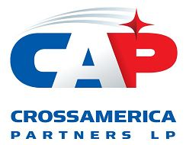
CrossAmerica Partners LP Reports Second Quarter 2026 Results
-
Reported Second Quarter of 2026 Net Income of $20.8 million, Adjusted EBITDA of $51.8 million and Distributable Cash Flow of $33.6 million compared to Net Income of $25.2 million, Adjusted EBITDA of $37.1 million and Distributable Cash Flow of $22.4 million for the Second Quarter of 2025
-
Reported Second Quarter of 2026 Gross Profit for the Retail Segment of $85.7 million compared to $76.1 million of Gross Profit for the Second Quarter of 2025 and Second Quarter of 2026 Gross Profit for the Wholesale Segment of $27.1 million compared to $24.9 million of Gross Profit for the Second Quarter of 2025
-
Leverage, as defined in the CAPL Credit Facility, was 3.57 times as of June 30, 2026, compared to 3.65 times as of June 30, 2025
-
The Distribution Coverage Ratio for the trailing twelve months ended June 30, 2026, was 1.39 times compared to 1.00 times for the comparable period of 2025
-
The Board of Directors of CrossAmerica's General Partner declared a quarterly distribution of $0.5250 per limited partner unit attributable to the Second Quarter of 2026
-
On July 20, 2026, Jonathan Benfield was appointed Chief Financial Officer

Allentown, PA August 5, 2026 – CrossAmerica Partners LP (NYSE: CAPL) (“CrossAmerica” or the “Partnership”), a leading wholesale fuels distributor, convenience store operator, and owner and lessor of real estate used in the retail distribution of motor fuels, today reported financial results for the second quarter ended June 30, 2026.

"The Partnership continued its strong start to the year, building on our very strong first quarter with another quarter of significant growth in Adjusted EBITDA and Distributable Cash Flow,” said Maura Topper, CEO and President of CrossAmerica. “I'm proud of how our team continued to execute with discipline through a volatile operating environment. One key area of success was our merchandise business with continued growth in merchandise margin percentage reflecting the strength of our convenience store operations and programs. Combined with our continued focus on cost management, these results allowed us to again pay down our credit facility during the quarter, further strengthening our balance sheet and providing increased flexibility and investment opportunities for the remainder of this year and beyond.”

1

Second Quarter Results
Consolidated Results
Key Operating Metrics | Q2 2026 | Q2 2025
Net Income | $20.8M | $25.2M
Adjusted EBITDA | $51.8M | $37.1M
Distributable Cash Flow | $33.6M | $22.4M
Distribution Coverage Ratio: Current Quarter | 1.68x | 1.12x
Distribution Coverage Ratio: Trailing 12 Months | 1.39x | 1.00x

CrossAmerica reported increases in Adjusted EBITDA, Distributable Cash Flow and Distribution Coverage for the second quarter of 2026 compared to the second quarter of 2025. The increase in Adjusted EBITDA was primarily driven by an increase in motor fuel margin per gallon in both the retail and wholesale segments, an increase in merchandise gross profit in the retail segment and an overall decline in operating expenses. The decline in Net Income was primarily driven by lower net gains in connection with CrossAmerica's ongoing real estate optimization efforts with $29.7 million in net gains for the second quarter of 2025 compared to $1.1 million in net gains for the second quarter of 2026.

The increase for the second quarter of 2026 in Distributable Cash Flow and Distribution Coverage was primarily driven by the increase in Adjusted EBITDA noted above in addition to a decrease in interest expense due to a lower average interest rate along with a lower average outstanding debt balance, partially offset by increases in sustaining capital expenditures and current income tax expense.

Retail Segment
Key Operating Metrics | Q2 2026 | Q2 2025
Retail segment gross profit | $85.7M | $76.1M
Retail segment motor fuel gallons distributed | 124.0M | 141.7M
Same store motor fuel gallons distributed | 117.8M | 132.6M
Retail segment motor fuel gross profit | $46.5M | $38.8M
Retail segment margin per gallon, before deducting credit card fees and commissions | $0.492 | $0.370
Same store merchandise sales excluding cigarettes* | $71.4M | $71.0M
Merchandise gross profit* | $31.0M | $30.5M
Merchandise gross profit percentage* | 29.5% | 28.2%
Operating Expenses | $48.7M | $50.8M
Retail Sites (average for period) | 560 | 603
*Includes only company operated retail sites

For the second quarter of 2026, the retail segment generated a 13% increase in gross profit compared to the second quarter of 2025, primarily due to increases in motor fuel, merchandise and other revenue gross profit compared to the prior year.

The motor fuel gross profit for the retail segment increased $7.7 million or 20%, attributable to a 33% increase in the margin per gallon for the three months ended June 30, 2026, as compared to the same period in 2025. The increase in margin per gallon was primarily driven by differences in movements in crude oil prices within the two periods and overall market volatility. The margin per gallon increase was partially offset by a motor fuel volume decrease of 12% driven by a decline in same store retail segment volume of 11% as well as a decrease in the average retail site count due to CrossAmerica's ongoing portfolio optimization efforts.

2

For the second quarter of 2026, CrossAmerica’s merchandise gross profit increased 2% when compared to the second quarter of 2025, despite a 9% decline in average company operated store count. Same store merchandise sales excluding cigarettes increased 1% for the second quarter of 2026 when compared to the second quarter of 2025. Merchandise gross profit percentage increased from 28.2% for the second quarter of 2025 to 29.5% for the second quarter of 2026. Other revenues increased $0.8 million or 18% driven by higher income from skills games and fuel sold on a commission basis.

Operating expenses for the retail segment declined $2.1 million dollars or 4% with same store operating expenses also declining for the second quarter of 2026 when compared to the same period in 2025. In addition, the average retail segment site count decreased 7% relative to the prior year due to CrossAmerica's ongoing portfolio optimization efforts.

Wholesale Segment
Key Operating Metrics | Q2 2026 | Q2 2025
Wholesale segment gross profit | $27.1M | $24.9M
Wholesale motor fuel gallons distributed | 160.3M | 179.2M
Average wholesale gross profit per gallon | $0.111 | $0.085

During the second quarter of 2026, CrossAmerica’s wholesale segment gross profit increased $2.2 million or 9% compared to the second quarter of 2025. The increase was primarily driven by a 17% or $2.6 million increase in motor fuel gross profit, partially offset by a 2% decline in rent gross profit. The decrease in rent gross profit was primarily due to the sale of locations and conversions to retail operations as part of the Partnership’s portfolio optimization efforts, partially offset by an increase in rent gross profit as a result of the reassessment of the accounting for CrossAmerica's lease with Getty required by the amendment of this lease during the first quarter of 2026.

The increase in motor fuel gross profit for the second quarter of 2026 when compared to the second quarter of 2025 was driven by a 31% increase in fuel margin per gallon, partially offset by an 11% decline in wholesale volume distributed. The decline in volume was primarily due to a reduction in volume in the base business as well as the loss of independent dealer contracts. Operating expenses declined $0.8 million or 11% due to the portfolio optimization efforts noted above.

Real Estate Activity

During the three months ended June 30, 2026, CrossAmerica sold five sites for $2.7 million in proceeds, resulting in a net gain of $1.1 million. CrossAmerica maintained a supply relationship post sale with substantially all of the locations divested during the quarter.

Liquidity and Capital Resources

As of June 30, 2026, CrossAmerica had $671.6 million outstanding under its Credit Facility. As of July 31, 2026, after taking into consideration debt covenant restrictions, approximately $244 million was available for future borrowings under the Credit Facility. Leverage, as defined in the Credit Facility, was 3.57 times as of June 30, 2026, compared to 3.65 times as of June 30, 2025. As of June 30, 2026, CrossAmerica was in compliance with its financial covenants under the Credit Facility.
3

Credit Facility

On July 15, 2026, the Partnership and its subsidiary, Lehigh Gas Wholesale Services, Inc. entered into an amendment to the Credit Facility. The Credit Facility Amendment, among other things extends the maturity date from March 31, 2028, to July 15, 2031, and removes the SOFR credit spread adjustment. Additional details regarding this amendment are available in a Form 8-K filing filed with the Securities and Exchange Commission (SEC) on July 16, 2026.

Distributions

On July 21, 2026, the Board of the Directors of CrossAmerica’s General Partner (“Board”) declared a quarterly distribution of $0.5250 per limited partner unit attributable to the second quarter of 2026. As previously announced, the distribution will be paid on August 13, 2026, to all unitholders of record as of August 3, 2026. The amount and timing of any future distributions is subject to the discretion of the Board as provided in CrossAmerica’s Partnership Agreement.

Conference Call

The Partnership will host a conference call on August 6, 2026, at 9:00 a.m. Eastern Time to discuss the second quarter of 2026 earnings results. The conference call numbers are 800-717-1738 or 646-307-1865 and the passcode for both is 292954. A live audio webcast of the conference call and the related earnings materials, including reconciliations of any non-GAAP financial measures to GAAP financial measures and any other applicable disclosures, will be available on that same day on the investor section of the CrossAmerica website (www.crossamericapartners.com). After the live conference call, an archive of the webcast will be available on the investor section of the CrossAmerica site at https://caplp.gcs-web.com/webcasts-presentations within 24 hours after the call for a period of sixty days.

Non-GAAP Measures and Same Store Metrics

Non-GAAP measures used in this release include EBITDA, Adjusted EBITDA, Distributable Cash Flow and Distribution Coverage Ratio. These Non-GAAP measures are further described and reconciled to their most directly comparable GAAP measures in the Supplemental Disclosure Regarding Non-GAAP Financial Measures section of this release.

Same store fuel volume and same store merchandise sales include aggregated individual store results for all stores that had fuel volume or merchandise sales and that were operated in the same class of trade for all months for both periods. Same store merchandise sales excludes other revenues such as lottery commissions and car wash sales.

4

CROSSAMERICA PARTNERS LP
CONSOLIDATED BALANCE SHEETS
(Thousands of Dollars, except unit data)
(Unaudited)

 |  | June 30, |  |  |  | December 31,
 |  | 2026 |  |  |  | 2025
ASSETS
Current assets:
Cash and cash equivalents |  | $ | 4,922 |  |  | $ | 3,137
Accounts receivable, net of allowances of $320 and $635, respectively |  |  | 33,834 |  |  |  | 28,566
Accounts receivable from related parties |  |  | 651 |  |  |  | 687
Inventory |  |  | 63,443 |  |  |  | 59,610
Assets held for sale |  |  | 9,755 |  |  |  | 9,690
Current portion of interest rate swap contracts |  |  | 2,291 |  |  |  | 801
Other current assets |  |  | 7,868 |  |  |  | 8,590
Total current assets |  |  | 122,764 |  |  |  | 111,081
Property and equipment, net |  |  | 579,475 |  |  |  | 547,686
Right-of-use assets, net |  |  | 101,463 |  |  |  | 121,636
Intangible assets, net |  |  | 54,406 |  |  |  | 61,638
Goodwill |  |  | 99,409 |  |  |  | 99,409
Deferred tax assets |  |  | — |  |  |  | 760
Interest rate swap contracts, less current portion |  |  | 1,855 |  |  |  | 325
Other assets |  |  | 22,614 |  |  |  | 22,199
Total assets |  | $ | 981,986 |  |  | $ | 964,734
LIABILITIES AND EQUITY
Current liabilities:
Current portion of debt and finance lease obligations |  | $ | 9,774 |  |  | $ | 3,465
Current portion of operating lease obligations |  |  | 24,584 |  |  |  | 29,008
Accounts payable |  |  | 77,725 |  |  |  | 63,413
Accounts payable to related parties |  |  | 7,792 |  |  |  | 6,536
Current portion of interest rate swap contracts |  |  | 184 |  |  |  | 697
Accrued expenses and other current liabilities |  |  | 25,360 |  |  |  | 27,378
Motor fuel and sales taxes payable |  |  | 16,409 |  |  |  | 19,013
Total current liabilities |  |  | 161,828 |  |  |  | 149,510
Debt and finance lease obligations, less current portion |  |  | 715,471 |  |  |  | 687,187
Operating lease obligations, less current portion |  |  | 80,680 |  |  |  | 96,974
Deferred tax liabilities, net |  |  | 7,479 |  |  |  | 7,409
Asset retirement obligations |  |  | 44,222 |  |  |  | 45,014
Interest rate swap contracts, less current portion |  |  | 109 |  |  |  | 1,390
Other long-term liabilities |  |  | 47,878 |  |  |  | 49,289
Total liabilities |  |  | 1,057,667 |  |  |  | 1,036,773
Commitments and contingencies (Note 9)
Preferred membership interests |  |  | 31,523 |  |  |  | 30,289
Equity:
Common units— 38,154,331 and 38,135,078 units issued and  outstanding at June 30, 2026 and December 31, 2025, respectively |  |  | (111,004 | ) |  |  | (101,280 | )
Accumulated other comprehensive income (loss) |  |  | 3,800 |  |  |  | (1,048 | )
Total deficit |  |  | (107,204 | ) |  |  | (102,328 | )
Total liabilities and equity |  | $ | 981,986 |  |  | $ | 964,734
5

CROSSAMERICA PARTNERS LP
CONSOLIDATED STATEMENTS OF OPERATIONS
(Thousands of Dollars, Except Unit and Per Unit Amounts)
(Unaudited)
 |  | Three Months Ended June 30, |  |  |  |  |  |  |  | Six Months Ended June 30,
 |  | 2026 |  |  |  | 2025 |  |  |  | 2026 |  |  |  | 2025
Operating revenues (a) |  | $ | 1,179,017 |  |  | $ | 961,925 |  |  | $ | 2,020,847 |  |  | $ | 1,824,400
Cost of sales (b) |  |  | 1,066,230 |  |  |  | 860,933 |  |  |  | 1,810,437 |  |  |  | 1,633,594
Gross profit |  |  | 112,787 |  |  |  | 100,992 |  |  |  | 210,410 |  |  |  | 190,806
Operating expenses:
Operating expenses (c) |  |  | 55,025 |  |  |  | 57,949 |  |  |  | 111,461 |  |  |  | 116,823
General and administrative expenses |  |  | 6,809 |  |  |  | 6,577 |  |  |  | 13,300 |  |  |  | 14,249
Depreciation, amortization and accretion expense |  |  | 16,768 |  |  |  | 23,334 |  |  |  | 33,830 |  |  |  | 49,638
Total operating expenses |  |  | 78,602 |  |  |  | 87,860 |  |  |  | 158,591 |  |  |  | 180,710
Gain on dispositions and lease terminations, net |  |  | 1,087 |  |  |  | 28,365 |  |  |  | 7,203 |  |  |  | 33,402
Operating income |  |  | 35,272 |  |  |  | 41,497 |  |  |  | 59,022 |  |  |  | 43,498
Other income, net |  |  | 212 |  |  |  | 136 |  |  |  | 369 |  |  |  | 266
Interest expense |  |  | (11,342 | ) |  |  | (12,569 | ) |  |  | (22,092 | ) |  |  | (25,413 | )
Income before income taxes |  |  | 24,142 |  |  |  | 29,064 |  |  |  | 37,299 |  |  |  | 18,351
Income tax expense |  |  | 3,330 |  |  |  | 3,896 |  |  |  | 5,828 |  |  |  | 298
Net income |  |  | 20,812 |  |  |  | 25,168 |  |  |  | 31,471 |  |  |  | 18,053
Accretion of preferred membership interests |  |  | 710 |  |  |  | 680 |  |  |  | 1,404 |  |  |  | 1,345
Net income available to limited partners |  | $ | 20,102 |  |  | $ | 24,488 |  |  | $ | 30,067 |  |  | $ | 16,708
Net income per common unit
Basic |  | $ | 0.53 |  |  | $ | 0.64 |  |  | $ | 0.79 |  |  | $ | 0.44
Diluted |  | $ | 0.52 |  |  | $ | 0.64 |  |  | $ | 0.78 |  |  | $ | 0.44
Weighted-average common units:
Basic |  |  | 38,154,331 |  |  |  | 38,097,513 |  |  |  | 38,148,481 |  |  |  | 38,085,815
Diluted |  |  | 38,323,956 |  |  |  | 39,545,478 |  |  |  | 38,318,067 |  |  |  | 38,260,908
Supplemental information:
(a) includes excise taxes of: |  | $ | 71,954 |  |  | $ | 82,903 |  |  | $ | 140,725 |  |  | $ | 156,253
(a) includes rent income of: |  |  | 14,666 |  |  |  | 15,459 |  |  |  | 29,226 |  |  |  | 32,661
(b) excludes depreciation, amortization and accretion
(b) includes rent expense of: |  |  | 3,766 |  |  |  | 4,923 |  |  |  | 7,883 |  |  |  | 9,818
(c) includes rent expense of: |  |  | 4,492 |  |  |  | 4,631 |  |  |  | 9,051 |  |  |  | 9,242

6

CROSSAMERICA PARTNERS LP
CONSOLIDATED STATEMENTS OF CASH FLOWS
(Thousands of Dollars)
(Unaudited)

 |  | Six Months Ended June 30,
 |  | 2026 |  |  |  | 2025
Cash flows from operating activities:
Net income |  | $ | 31,471 |  |  | $ | 18,053
Adjustments to reconcile net income to net cash provided by operating activities:
Depreciation, amortization and accretion expense |  |  | 33,830 |  |  |  | 49,638
Amortization of deferred financing costs |  |  | 968 |  |  |  | 969
Credit loss expense |  |  | 24 |  |  |  | —
Deferred income tax expense (benefit) |  |  | 830 |  |  |  | (2,696 | )
Equity-based employee and director compensation expense |  |  | 788 |  |  |  | 989
Gain on dispositions and lease terminations, net |  |  | (7,203 | ) |  |  | (33,402 | )
Changes in operating assets and liabilities, net of acquisitions |  |  | 397 |  |  |  | 4,146
Net cash provided by operating activities |  |  | 61,105 |  |  |  | 37,697
Cash flows from investing activities:
Principal payments received on notes receivable |  |  | 127 |  |  |  | 63
Proceeds from sale of assets |  |  | 16,252 |  |  |  | 72,766
Capital expenditures |  |  | (10,874 | ) |  |  | (21,958 | )
Cash paid in connection with acquisitions, net of cash acquired |  |  | (1,800 | ) |  |  | —
Net cash provided by investing activities |  |  | 3,705 |  |  |  | 50,871
Cash flows from financing activities:
Borrowings under the Credit Facility |  |  | 49,500 |  |  |  | 41,000
Repayments on the Credit Facility |  |  | (70,200 | ) |  |  | (81,500 | )
Payments of finance lease obligations |  |  | (1,964 | ) |  |  | (1,604 | )
Distributions paid on distribution equivalent rights |  |  | (139 | ) |  |  | (146 | )
Distributions paid to preferred membership interests |  |  | (170 | ) |  |  | —
Distributions paid on common units |  |  | (40,052 | ) |  |  | (39,982 | )
Net cash used in financing activities |  |  | (63,025 | ) |  |  | (82,232 | )
Net increase in cash and cash equivalents |  |  | 1,785 |  |  |  | 6,336
Cash and cash equivalents at beginning of period |  |  | 3,137 |  |  |  | 3,381
Cash and cash equivalents at end of period |  | $ | 4,922 |  |  | $ | 9,717

7

Segment Results
Retail
The following table highlights the results of operations and certain operating metrics of the Retail segment (in thousands, except for the number of retail sites and per gallon amounts):
 |  | Three Months Ended June 30, |  |  |  |  |  |  |  | Six Months Ended June 30,
 |  | 2026 |  |  |  | 2025 |  |  |  | 2026 |  |  |  | 2025
Gross profit:
Motor fuel |  | $ | 46,461 |  |  | $ | 38,789 |  |  | $ | 86,321 |  |  | $ | 69,970
Merchandise |  |  | 31,026 |  |  |  | 30,506 |  |  |  | 57,978 |  |  |  | 55,419
Rent |  |  | 2,753 |  |  |  | 2,224 |  |  |  | 5,435 |  |  |  | 4,835
Other revenue |  |  | 5,450 |  |  |  | 4,608 |  |  |  | 10,259 |  |  |  | 9,063
Total gross profit |  |  | 85,690 |  |  |  | 76,127 |  |  |  | 159,993 |  |  |  | 139,287
Operating expenses |  |  | (48,695 | ) |  |  | (50,828 | ) |  |  | (98,694 | ) |  |  | (102,532 | )
Operating income |  | $ | 36,995 |  |  | $ | 25,299 |  |  | $ | 61,299 |  |  | $ | 36,755
Retail sites (end of period):
Company operated retail sites (a) |  |  | 334 |  |  |  | 361 |  |  |  | 334 |  |  |  | 361
Commission agents (b) |  |  | 221 |  |  |  | 236 |  |  |  | 221 |  |  |  | 236
Total retail sites |  |  | 555 |  |  |  | 597 |  |  |  | 555 |  |  |  | 597
Total retail segment statistics:
Volume of gallons sold |  |  | 124,032 |  |  |  | 141,683 |  |  |  | 241,718 |  |  |  | 268,216
Same store total system gallons sold(c) |  |  | 117,773 |  |  |  | 132,608 |  |  |  | 222,160 |  |  |  | 245,448
Average retail fuel sites |  |  | 560 |  |  |  | 603 |  |  |  | 568 |  |  |  | 600
Margin per gallon, before deducting credit card fees and commissions |  | $ | 0.492 |  |  | $ | 0.370 |  |  | $ | 0.465 |  |  | $ | 0.355
Company operated site statistics:
Average retail fuel sites |  |  | 336 |  |  |  | 368 |  |  |  | 341 |  |  |  | 367
Same store fuel volume(c) |  |  | 85,329 |  |  |  | 92,858 |  |  |  | 158,947 |  |  |  | 169,817
Margin per gallon, before deducting credit card fees |  | $ | 0.513 |  |  | $ | 0.395 |  |  | $ | 0.486 |  |  | $ | 0.385
Same store merchandise sales(c) |  | $ | 98,013 |  |  | $ | 98,224 |  |  | $ | 177,683 |  |  | $ | 176,791
Same store merchandise sales excluding cigarettes(c) |  | $ | 71,411 |  |  | $ | 70,966 |  |  | $ | 128,382 |  |  | $ | 126,754
Merchandise gross profit percentage |  |  | 29.5 | % |  |  | 28.2 | % |  |  | 29.6 | % |  |  | 28.1 | %
Commission site statistics:
Average retail fuel sites |  |  | 224 |  |  |  | 235 |  |  |  | 227 |  |  |  | 233
Margin per gallon, before deducting credit card fees and commissions |  | $ | 0.436 |  |  | $ | 0.313 |  |  | $ | 0.411 |  |  | $ | 0.289

(a) The decrease in the company operated site count was primarily attributable to the sale of certain company operated sites in connection with CrossAmerica's real estate optimization effort.
(b) The decrease in the commission agent site count was primarily attributable to the sale of certain commission agent sites in connection with CrossAmerica's real estate optimization effort.
(c) Same store fuel volume and same store merchandise sales include aggregated individual store results for all stores that had fuel volume or merchandise sales and that were operated in the same class of trade for all months for both periods. Same store merchandise sales excludes other revenues such as lottery commissions and car wash sales.

8

Wholesale

The following table highlights the results of operations and certain operating metrics of the Wholesale segment (thousands of dollars, except for the number of distribution sites and per gallon amounts):
 |  | Three Months Ended June 30, |  |  |  |  |  |  |  | Six Months Ended June 30,
 |  | 2026 |  |  |  | 2025 |  |  |  | 2026 |  |  |  | 2025
Gross profit:
Motor fuel gross profit |  | $ | 17,801 |  |  | $ | 15,165 |  |  | $ | 32,254 |  |  | $ | 30,928
Rent gross profit |  |  | 8,147 |  |  |  | 8,312 |  |  |  | 15,908 |  |  |  | 18,008
Other revenues |  |  | 1,149 |  |  |  | 1,388 |  |  |  | 2,255 |  |  |  | 2,583
Total gross profit |  |  | 27,097 |  |  |  | 24,865 |  |  |  | 50,417 |  |  |  | 51,519
Operating expenses |  |  | (6,330 | ) |  |  | (7,121 | ) |  |  | (12,767 | ) |  |  | (14,291 | )
Operating income |  | $ | 20,767 |  |  | $ | 17,744 |  |  | $ | 37,650 |  |  | $ | 37,228
Motor fuel distribution sites (end of period): (a)
Independent dealers (b) |  |  | 664 |  |  |  | 639 |  |  |  | 664 |  |  |  | 639
Lessee dealers (c) |  |  | 317 |  |  |  | 365 |  |  |  | 317 |  |  |  | 365
Total motor fuel distribution sites |  |  | 981 |  |  |  | 1,004 |  |  |  | 981 |  |  |  | 1,004
Average motor fuel distribution sites |  |  | 984 |  |  |  | 1,009 |  |  |  | 985 |  |  |  | 1,021
Volume of gallons distributed |  |  | 160,276 |  |  |  | 179,241 |  |  |  | 313,864 |  |  |  | 342,159
Margin per gallon |  | $ | 0.111 |  |  | $ | 0.085 |  |  | $ | 0.103 |  |  | $ | 0.090

(a) In addition, CrossAmerica distributed motor fuel to sub-wholesalers who distributed to additional sites.
(b) The increase in the independent dealer site count was primarily attributable to the sale of certain lessee dealer, company operated and commission agent sites but with continued fuel supply, partially offset by the net loss of independent dealer contracts.
(c) The decrease in the lessee dealer count was primarily attributable to the sale of certain lessee dealer sites in connection with CrossAmerica's real estate optimization effort (generally with continued fuel supply, thereby converting the site to an independent dealer site) as well as the conversion of certain lessee dealer sites to company operated and commission agent sites.

9

Supplemental Disclosure Regarding Non-GAAP Financial Measures

CrossAmerica uses the non-GAAP financial measures EBITDA, Adjusted EBITDA, Distributable Cash Flow and Distribution Coverage Ratio. EBITDA represents net income (loss) before deducting interest expense, income taxes and depreciation, amortization and accretion (which includes certain impairment charges). Adjusted EBITDA represents EBITDA as further adjusted to exclude equity-based compensation expense, gains or losses on dispositions and lease terminations, net and certain discrete acquisition related costs, such as legal and other professional fees, separation benefit costs and certain other discrete non-cash items arising from purchase accounting. Distributable Cash Flow represents Adjusted EBITDA less cash interest expense, sustaining capital expenditures and current income tax expense. The Distribution Coverage Ratio is computed by dividing Distributable Cash Flow by distributions paid on common units.

EBITDA, Adjusted EBITDA, Distributable Cash Flow and Distribution Coverage Ratio are used as supplemental financial measures by management and by external users of our financial statements, such as investors and lenders. EBITDA and Adjusted EBITDA are used to assess CrossAmerica’s financial performance without regard to financing methods, capital structure or income taxes and the ability to incur and service debt and to fund capital expenditures. In addition, Adjusted EBITDA is used to assess the operating performance of the Partnership’s business on a consistent basis by excluding the impact of items which do not result directly from the wholesale distribution of motor fuel, the leasing of real property, or the day to day operations of CrossAmerica’s retail site activities. EBITDA, Adjusted EBITDA, Distributable Cash Flow and Distribution Coverage Ratio are also used to assess the ability to generate cash sufficient to make distributions to CrossAmerica’s unitholders.

CrossAmerica believes the presentation of EBITDA, Adjusted EBITDA, Distributable Cash Flow and Distribution Coverage Ratio provides useful information to investors in assessing the financial condition and results of operations. EBITDA, Adjusted EBITDA, Distributable Cash Flow and Distribution Coverage Ratio should not be considered alternatives to net income or any other measure of financial performance or liquidity presented in accordance with U.S. GAAP. EBITDA, Adjusted EBITDA, Distributable Cash Flow and Distribution Coverage Ratio have important limitations as analytical tools because they exclude some but not all items that affect net income. Additionally, because EBITDA, Adjusted EBITDA, Distributable Cash Flow and Distribution Coverage Ratio may be defined differently by other companies in the industry, CrossAmerica’s definitions may not be comparable to similarly titled measures of other companies, thereby diminishing their utility.

The following table presents reconciliations of EBITDA, Adjusted EBITDA, and Distributable Cash Flow to net income (loss), the most directly comparable U.S. GAAP financial measure, for each of the periods indicated (in thousands, except for Distribution Coverage Ratio):

 |  | Three Months Ended June 30, |  |  |  |  |  |  |  | Six Months Ended June 30,
 |  | 2026 |  |  |  | 2025 |  |  |  | 2026 |  |  |  | 2025
Net income |  | $ | 20,812 |  |  | $ | 25,168 |  |  | $ | 31,471 |  |  | $ | 18,053
Interest expense |  |  | 11,342 |  |  |  | 12,569 |  |  |  | 22,092 |  |  |  | 25,413
Income tax expense |  |  | 3,330 |  |  |  | 3,896 |  |  |  | 5,828 |  |  |  | 298
Depreciation, amortization and accretion expense |  |  | 16,768 |  |  |  | 23,334 |  |  |  | 33,830 |  |  |  | 49,638
EBITDA |  |  | 52,252 |  |  |  | 64,967 |  |  |  | 93,221 |  |  |  | 93,402
Equity-based employee and director compensation expense |  |  | 587 |  |  |  | 176 |  |  |  | 788 |  |  |  | 989
Gain on dispositions and lease terminations, net (a) |  |  | (1,087 | ) |  |  | (28,365 | ) |  |  | (7,203 | ) |  |  | (33,402 | )
Acquisition-related costs (b) |  |  | 17 |  |  |  | 305 |  |  |  | 44 |  |  |  | 363
Adjusted EBITDA |  |  | 51,769 |  |  |  | 37,083 |  |  |  | 86,850 |  |  |  | 61,352
Cash interest expense |  |  | (10,858 | ) |  |  | (12,085 | ) |  |  | (21,123 | ) |  |  | (24,444 | )
Sustaining capital expenditures (c) |  |  | (4,952 | ) |  |  | (2,550 | ) |  |  | (6,302 | ) |  |  | (5,271 | )
Current income tax expense (d) |  |  | (2,378 | ) |  |  | (52 | ) |  |  | (4,342 | ) |  |  | (146 | )
Distributable Cash Flow |  | $ | 33,581 |  |  | $ | 22,396 |  |  | $ | 55,083 |  |  | $ | 31,491
Distributions paid on common units |  |  | 20,031 |  |  |  | 20,001 |  |  |  | 40,052 |  |  |  | 39,982
Distribution Coverage Ratio |  | 1.68x |  |  |  | 1.12x |  |  |  | 1.38x |  |  |  | 0.79x

10

(a) Primarily includes net gains in connection with CrossAmerica's ongoing real estate optimization effort of $1.1 million and $29.7 million for the three months ended June 30, 2026, and 2025, and $7.4 million and $35.2 million for the six months ended June 30, 2026, and 2025, respectively.
(b) Relates to certain acquisition-related costs, such as legal and other professional fees, separation benefit costs and purchase accounting adjustments associated with recent acquisitions.
(c) Under the Partnership Agreement, sustaining capital expenditures are capital expenditures made to maintain CrossAmerica's long-term operating income or operating capacity. Examples of sustaining capital expenditures are those made to maintain existing contract volumes or to maintain the sites in conditions suitable to operate or lease, such as parking lot or roof replacement/renovation, or to replace equipment required to operate the existing business.
(d) Excludes current income tax expense incurred on the sales of sites.

About CrossAmerica Partners LP
CrossAmerica Partners LP is a leading wholesale distributor of motor fuels, convenience store operator, and owner and lessee of real estate used in the retail distribution of motor fuels. Its general partner, CrossAmerica GP LLC, is indirectly owned and controlled by entities affiliated with Joseph V. Topper, Jr., the founder of CrossAmerica Partners and a member of the board of the general partner since 2012. Formed in 2012, CrossAmerica Partners LP is a distributor of branded and unbranded petroleum for motor vehicles in the United States and distributes fuel to approximately 1,500 locations and owns or leases approximately 900 sites. With a geographic footprint covering 34 states, the Partnership has well-established relationships with several major oil brands, including ExxonMobil, BP, Shell, Marathon, Valero, Phillips 66 and other major brands. CrossAmerica Partners LP ranks as one of ExxonMobil’s largest distributors by fuel volume in the United States and in the top 10 for additional brands. For additional information, please visit www.crossamericapartners.com.
Contact
Investor Relations: Randy Palmer, rpalmer@caplp.com or 610-625-8000
Cautionary Statement Regarding Forward-Looking Statements
Statements contained in this release that state the Partnership’s or management’s expectations or predictions of the future are forward-looking statements. The words “believe,” “expect,” “should,” “intends,” “estimates,” “target” and other similar expressions identify forward-looking statements. It is important to note that actual results could differ materially from those projected in such forward-looking statements. For more information concerning factors that could cause actual results to differ from those expressed or forecasted, see CrossAmerica’s Form 10-K or Forms 10-Q filed with the Securities and Exchange Commission, and available on CrossAmerica’s website at www.crossamericapartners.com. The Partnership undertakes no obligation to publicly update or revise any statements in this release, whether as a result of new information, future events or otherwise.

11

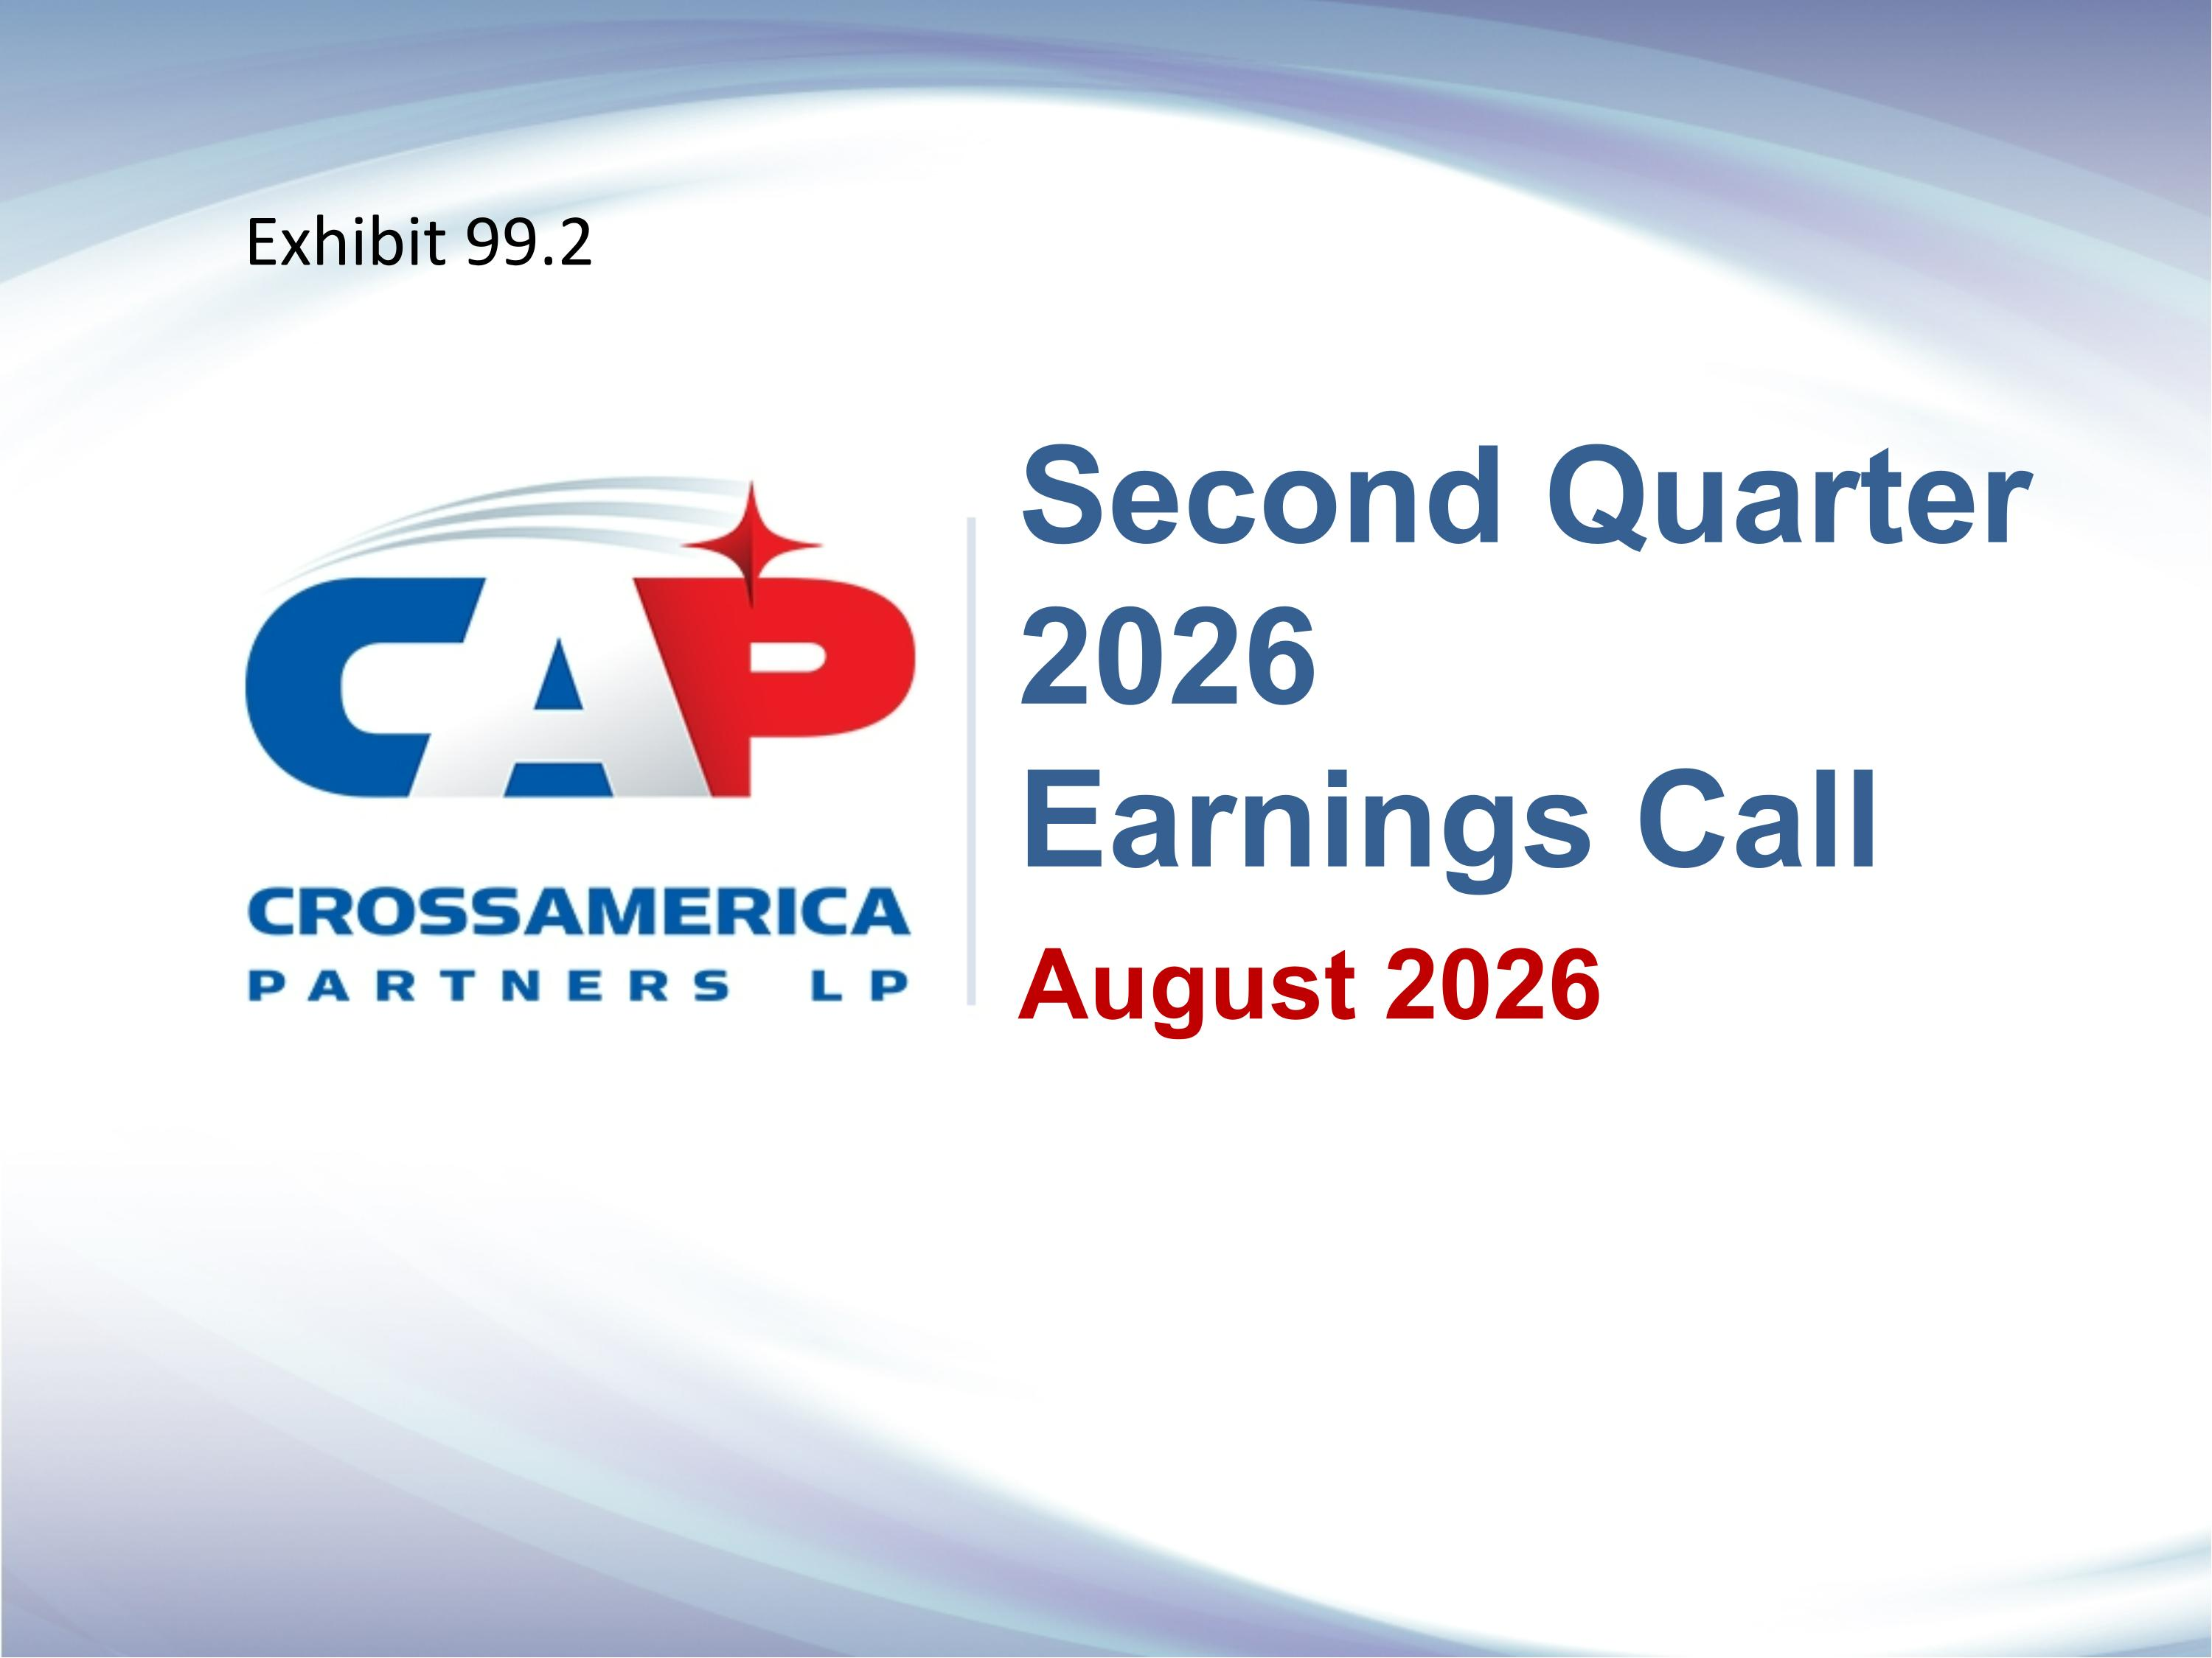
August 2026 Second Quarter 2026 ?Earnings Call Exhibit 99.2

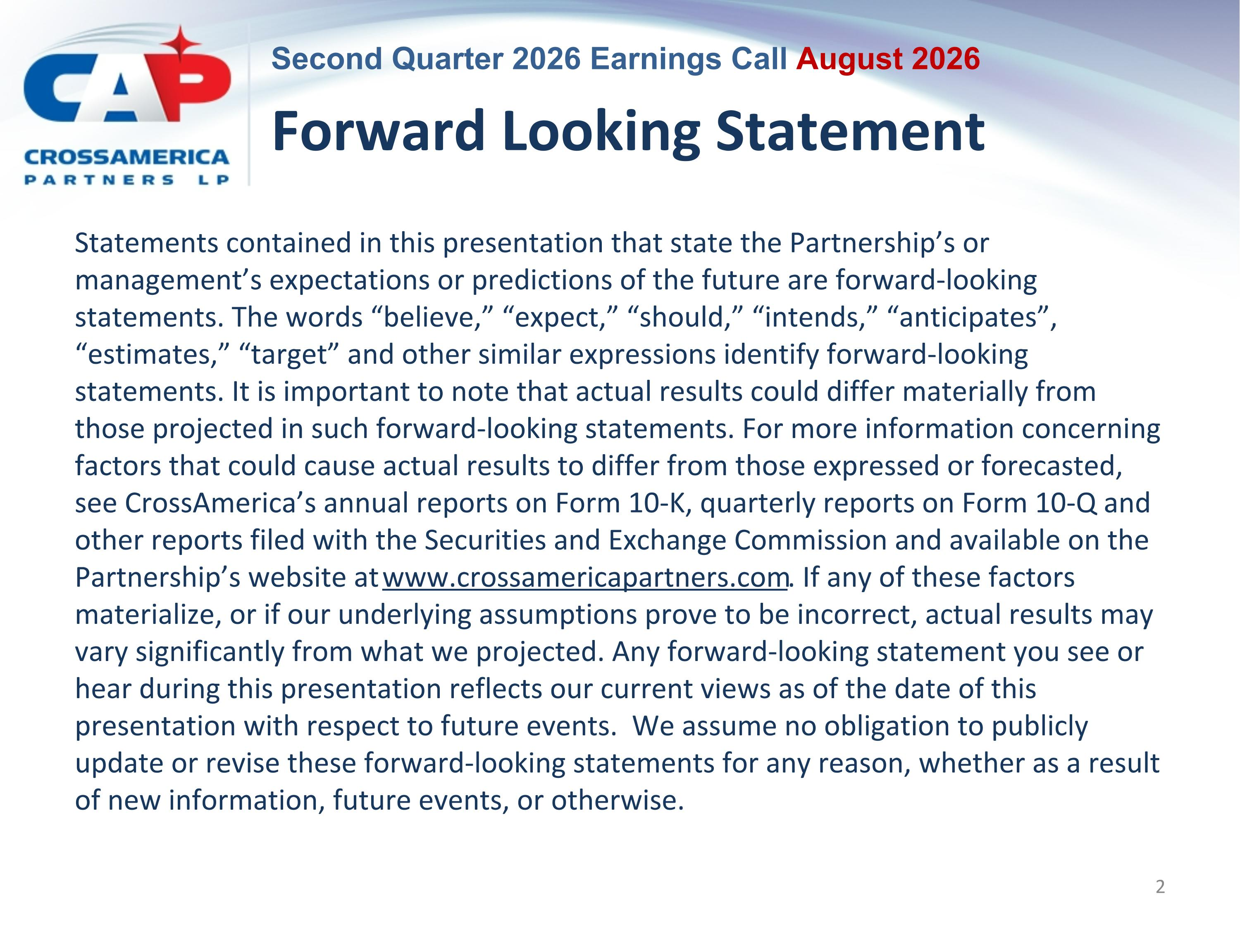
Forward Looking Statement Statements contained in this presentation that state the Partnership’s or management’s expectations or predictions of the future are forward-looking statements. The words “believe,” “expect,” “should,” “intends,” “anticipates”, “estimates,” “target” and other similar expressions identify forward-looking statements. It is important to note that actual results could differ materially from those projected in such forward-looking statements. For more information concerning factors that could cause actual results to differ from those expressed or forecasted, see CrossAmerica’s annual reports on Form 10-K, quarterly reports on Form 10-Q and other reports filed with the Securities and Exchange Commission and available on the Partnership’s website at www.crossamericapartners.com. If any of these factors materialize, or if our underlying assumptions prove to be incorrect, actual results may vary significantly from what we projected. Any forward-looking statement you see or hear during this presentation reflects our current views as of the date of this presentation with respect to future events. We assume no obligation to publicly update or revise these forward-looking statements for any reason, whether as a result of new information, future events, or otherwise.

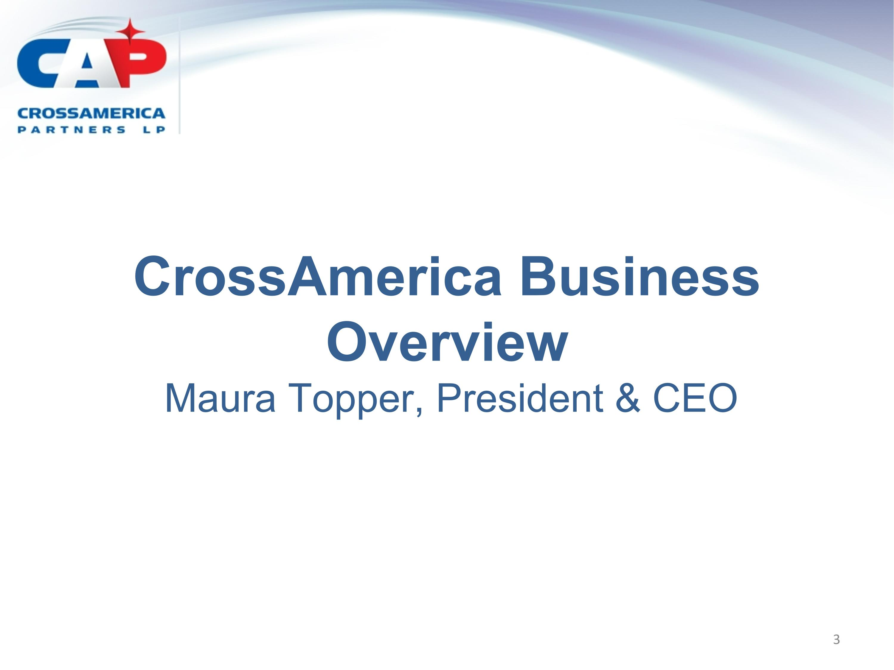
CrossAmerica Business Overview?Maura Topper, President & CEO

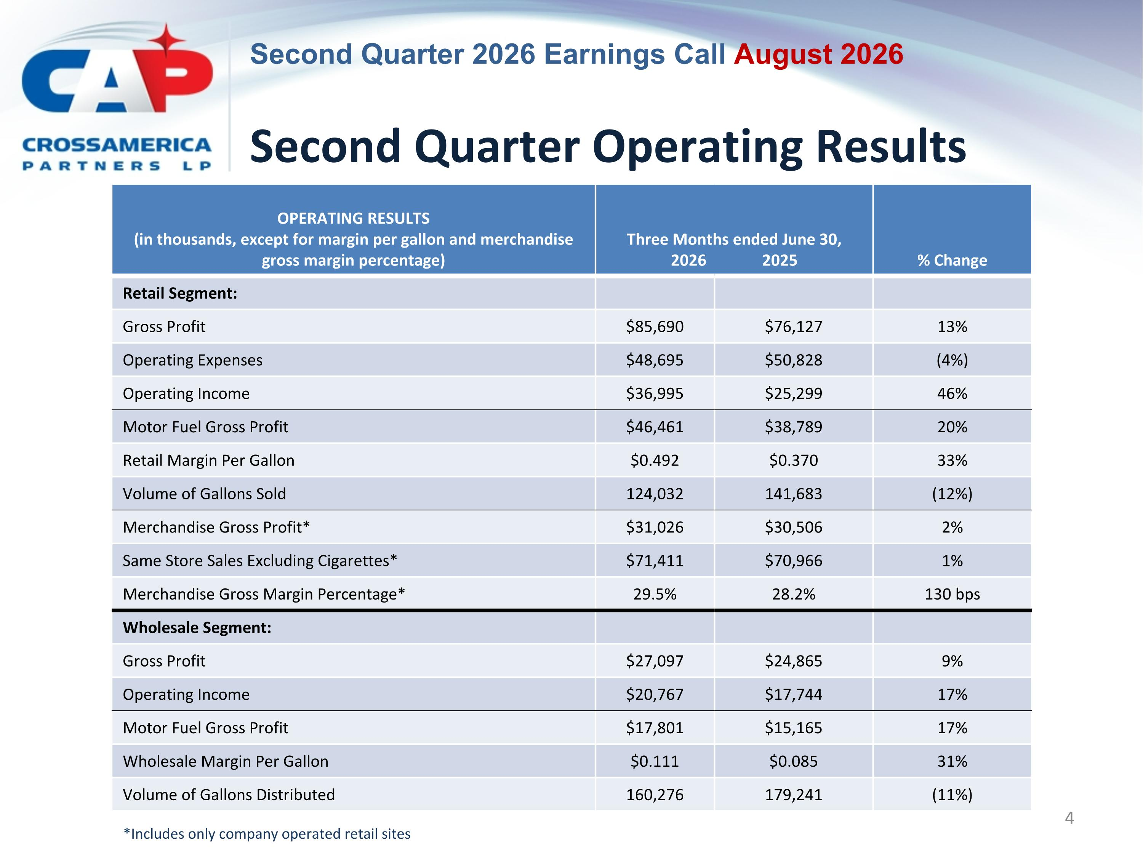
Second Quarter Operating Results OPERATING RESULTS (in thousands, except for margin per gallon and merchandise gross margin percentage) Three Months ended June 30, 2026 2025 % Change Retail Segment: Gross Profit $85,690 $76,127 13% Operating Expenses $48,695 $50,828 (4%) Operating Income $36,995 $25,299 46% Motor Fuel Gross Profit $46,461 $38,789 20% Retail Margin Per Gallon $0.492 $0.370 33% Volume of Gallons Sold 124,032 141,683 (12%) Merchandise Gross Profit* $31,026 $30,506 2% Same Store Sales Excluding Cigarettes* $71,411 $70,966 1% Merchandise Gross Margin Percentage* 29.5% 28.2% 130 bps Wholesale Segment: Gross Profit $27,097 $24,865 9% Operating Income $20,767 $17,744 17% Motor Fuel Gross Profit $17,801 $15,165 17% Wholesale Margin Per Gallon $0.111 $0.085 31% Volume of Gallons Distributed 160,276 179,241 (11%) *Includes only company operated retail sites

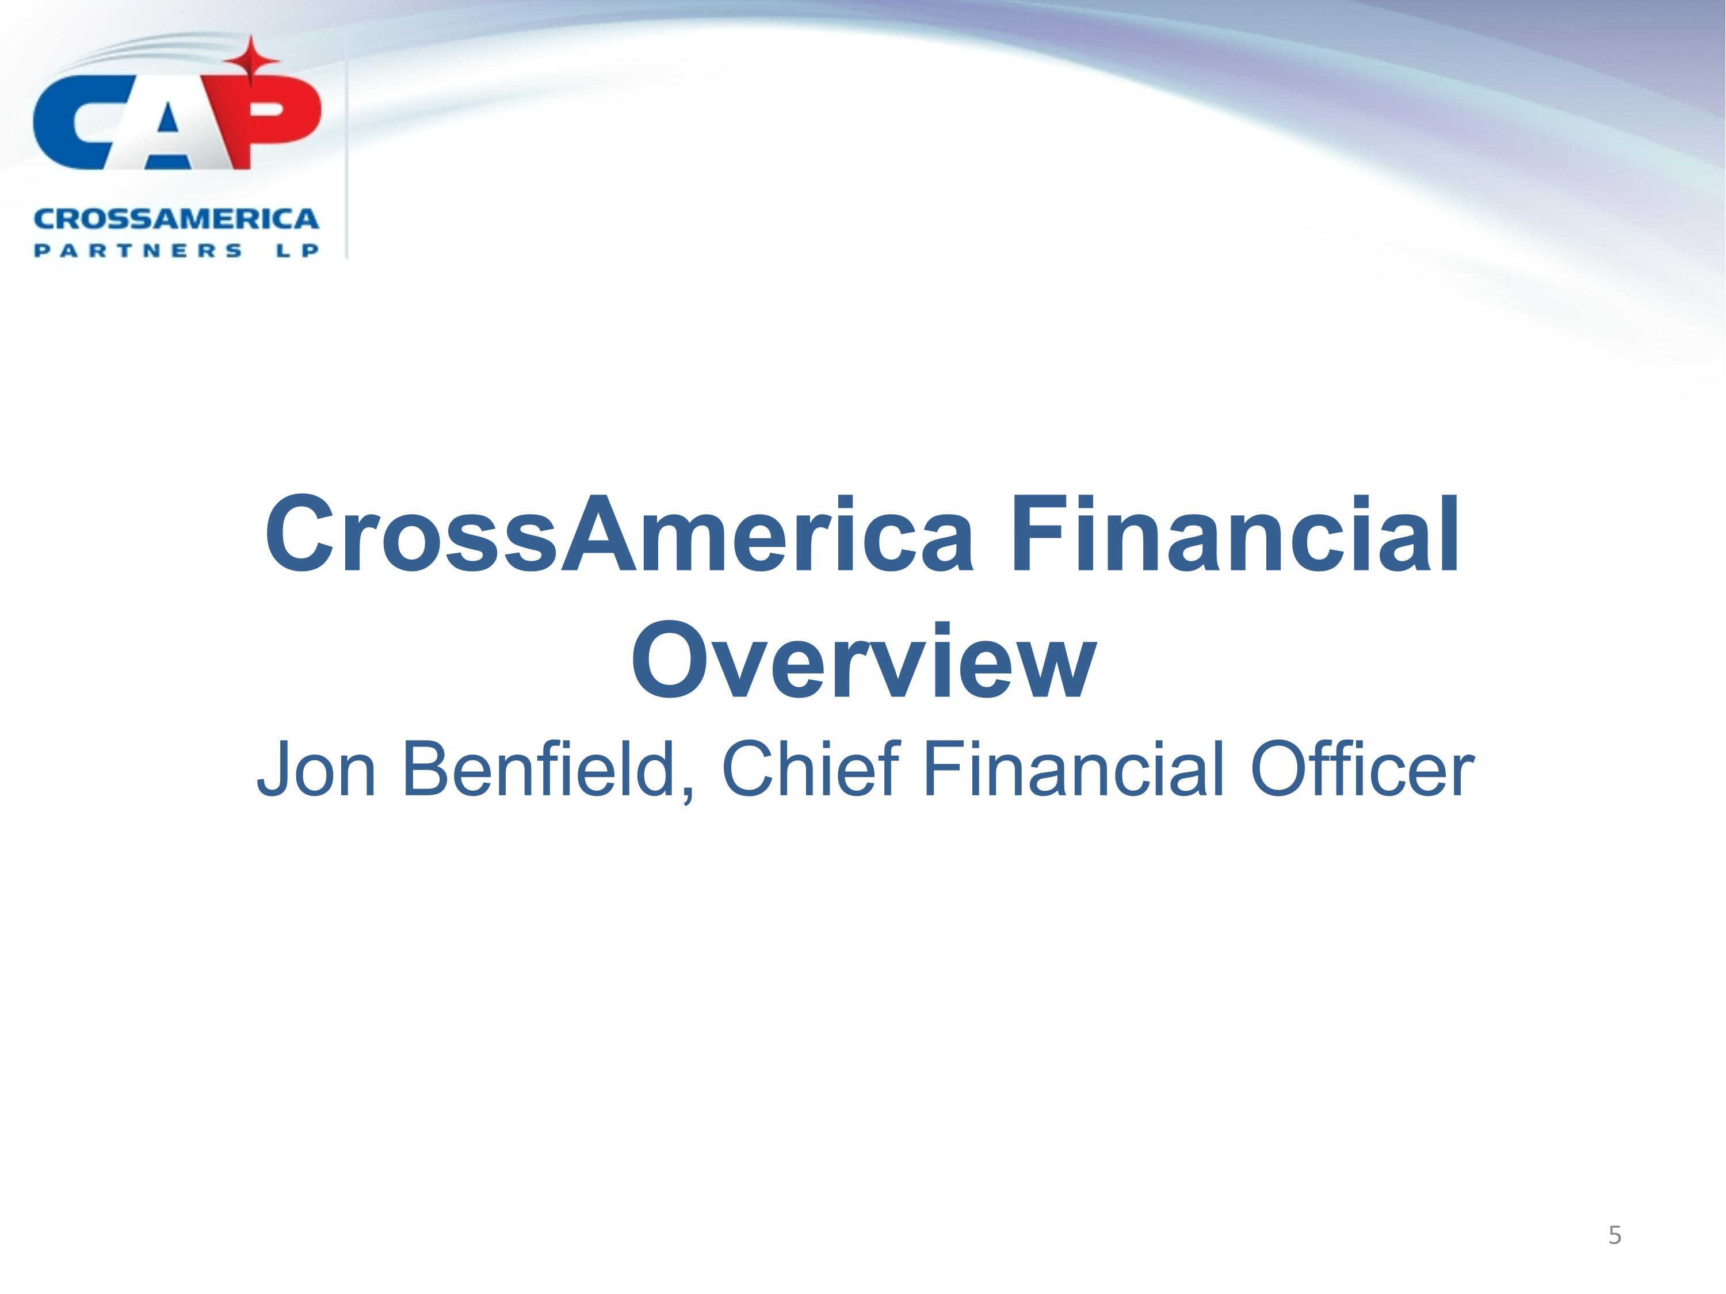
CrossAmerica Financial Overview?Jon Benfield, Chief Financial Officer

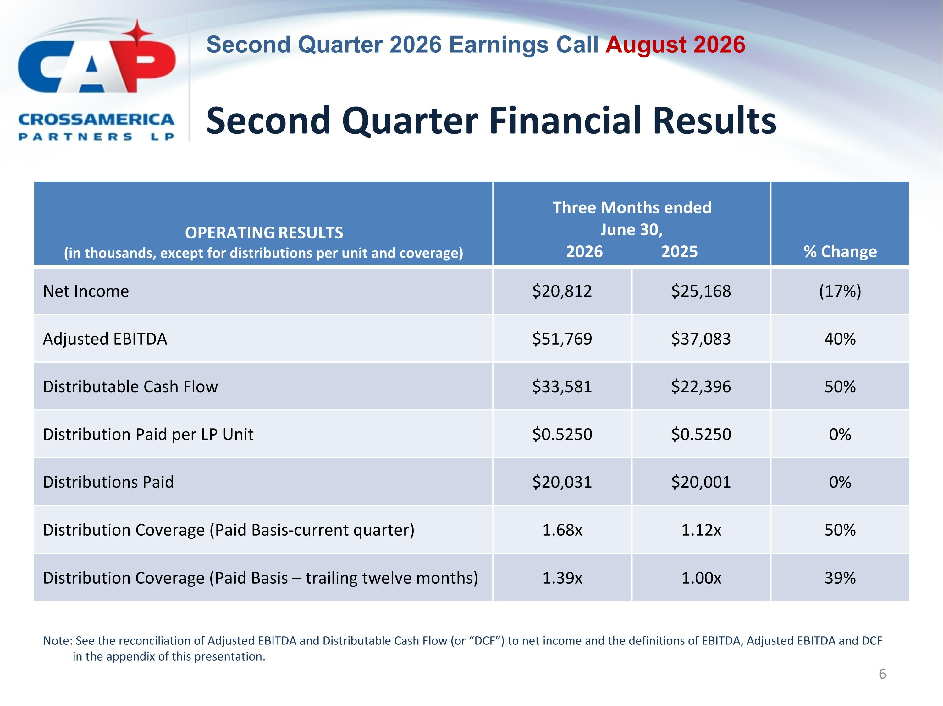
Second Quarter Financial Results OPERATING RESULTS (in thousands, except for distributions per unit and coverage) Three Months ended June 30,?2026 2025 % Change Net Income $20,812 $25,168 (17%) Adjusted EBITDA $51,769 $37,083 40% Distributable Cash Flow $33,581 $22,396 50% Distribution Paid per LP Unit $0.5250 $0.5250 0% Distributions Paid $20,031 $20,001 0% Distribution Coverage (Paid Basis-current quarter) 1.68x 1.12x 50% Distribution Coverage (Paid Basis – trailing twelve months) 1.39x 1.00x 39% Note: See the reconciliation of Adjusted EBITDA and Distributable Cash Flow (or “DCF”) to net income and the definitions of EBITDA, Adjusted EBITDA and DCF in the appendix of this presentation.

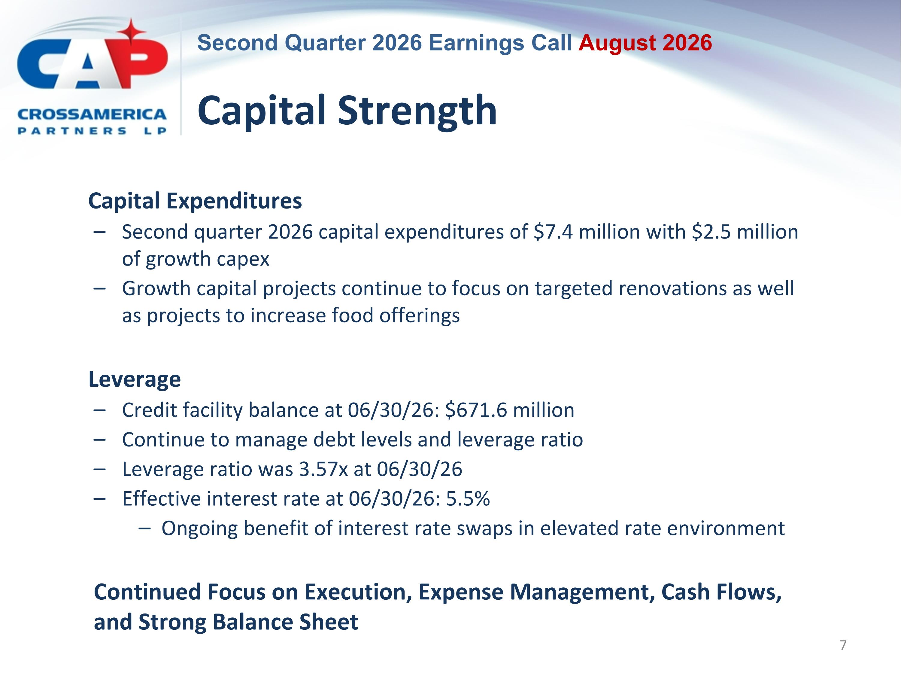
Capital Strength Capital Expenditures Second quarter 2026 capital expenditures of $7.4 million with $2.5 million of growth capex Growth capital projects continue to focus on targeted renovations as well as projects to increase food offerings Leverage Credit facility balance at 06/30/26: $671.6 million Continue to manage debt levels and leverage ratio Leverage ratio was 3.57x at 06/30/26 Effective interest rate at 06/30/26: 5.5% Ongoing benefit of interest rate swaps in elevated rate environment Continued Focus on Execution, Expense Management, Cash Flows, and Strong Balance Sheet

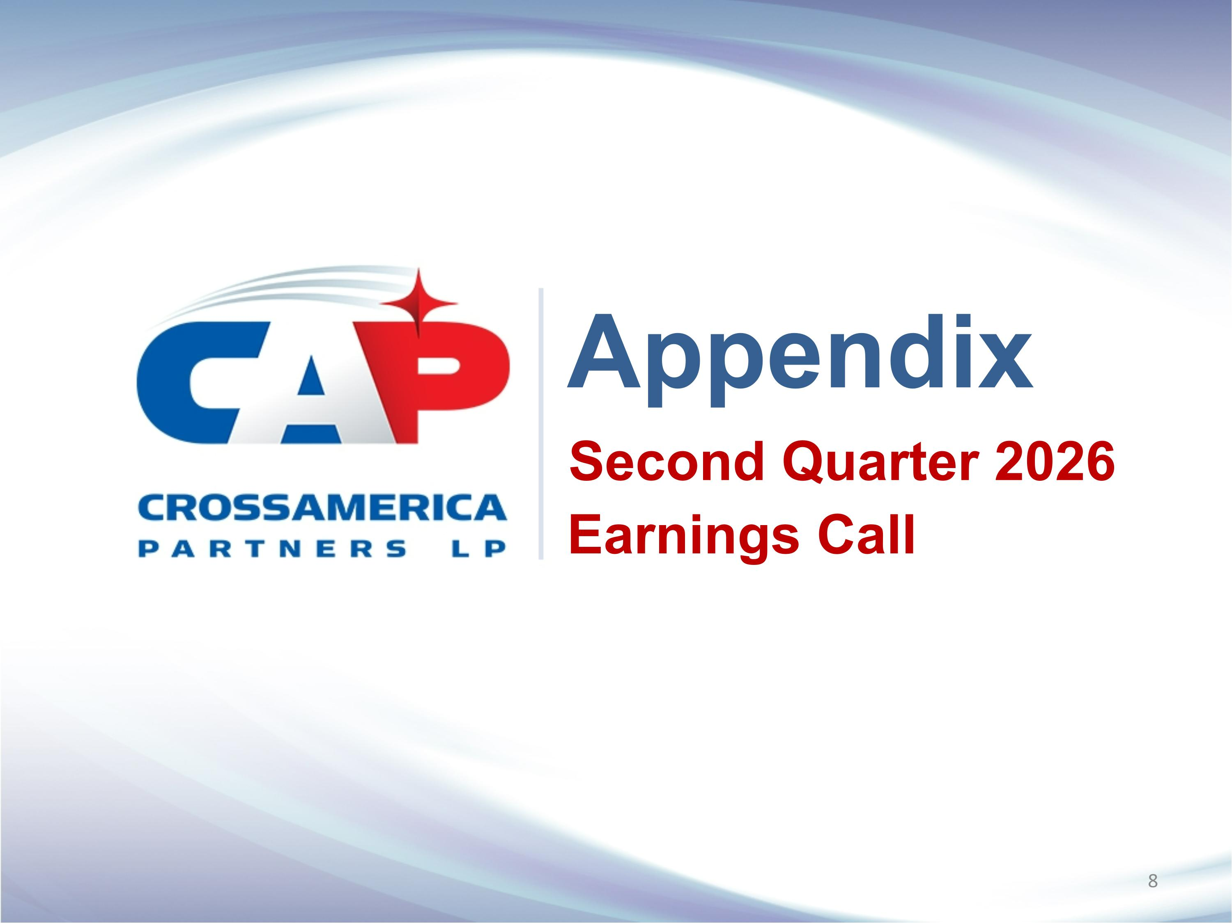
Appendix Second Quarter 2026 Earnings Call

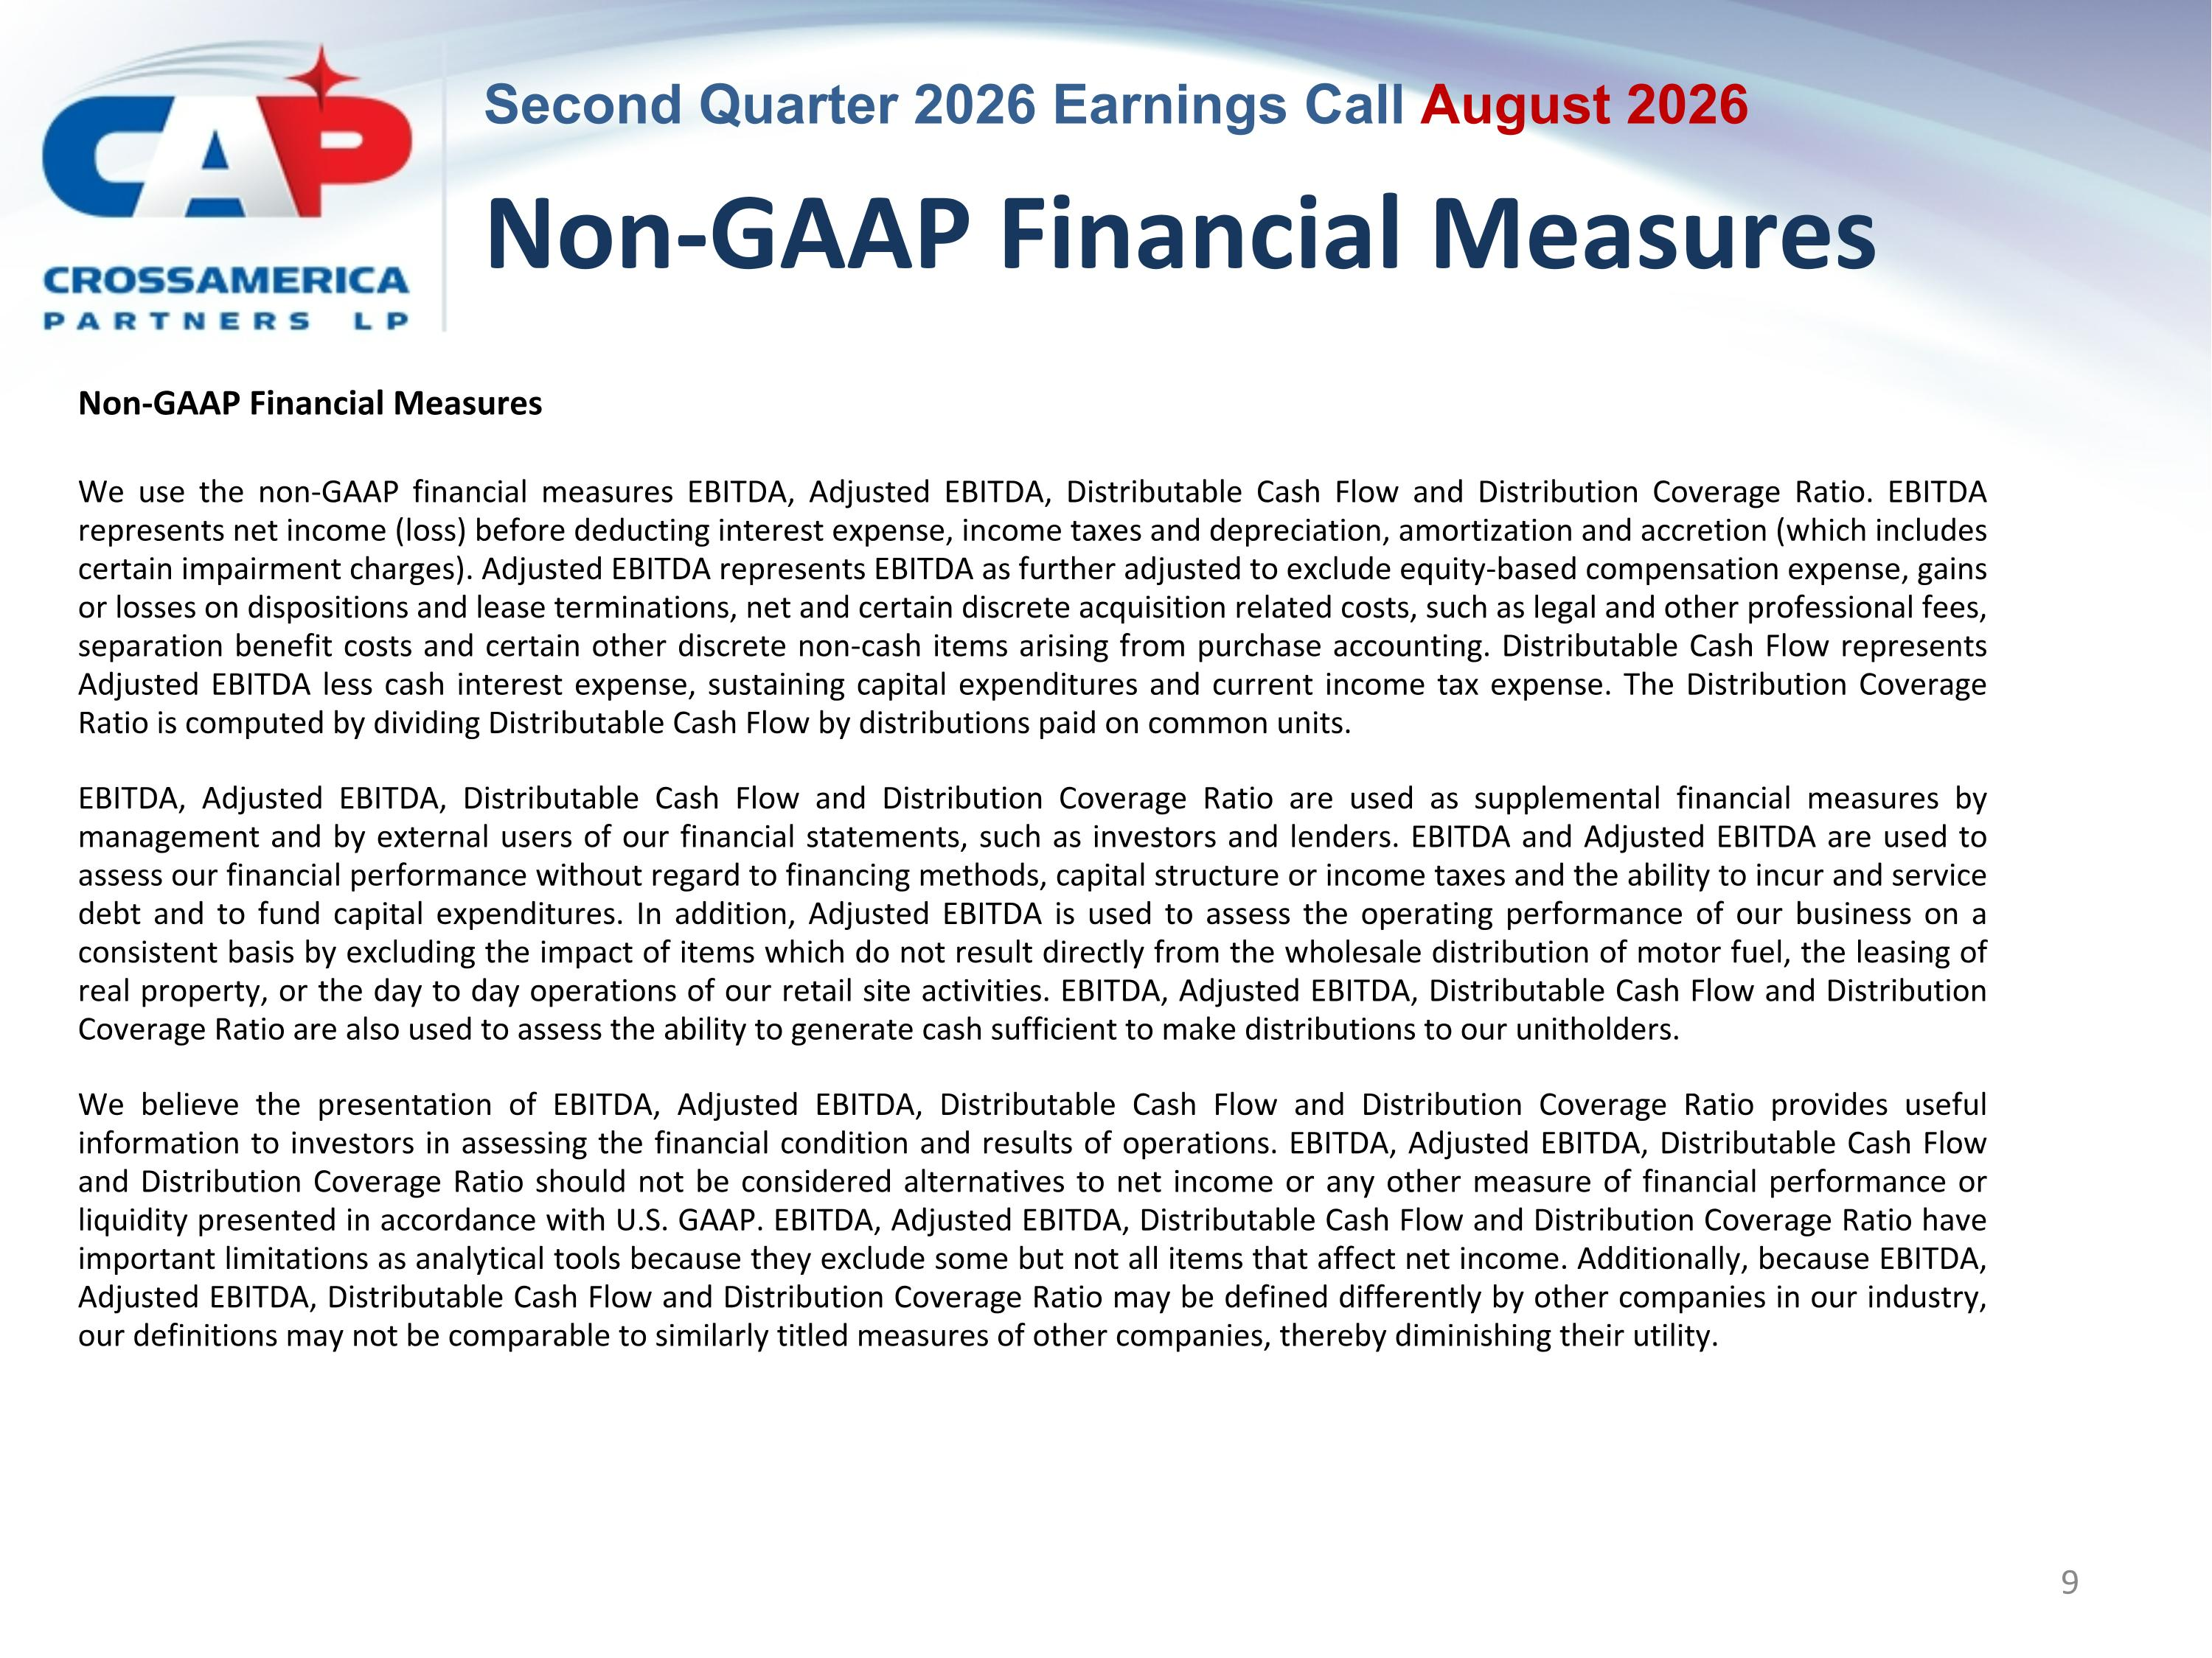
Non-GAAP Financial Measures Non-GAAP Financial Measures We use the non-GAAP financial measures EBITDA, Adjusted EBITDA, Distributable Cash Flow and Distribution Coverage Ratio. EBITDA represents net income (loss) before deducting interest expense, income taxes and depreciation, amortization and accretion (which includes certain impairment charges). Adjusted EBITDA represents EBITDA as further adjusted to exclude equity-based compensation expense, gains or losses on dispositions and lease terminations, net and certain discrete acquisition related costs, such as legal and other professional fees, separation benefit costs and certain other discrete non-cash items arising from purchase accounting. Distributable Cash Flow represents Adjusted EBITDA less cash interest expense, sustaining capital expenditures and current income tax expense. The Distribution Coverage Ratio is computed by dividing Distributable Cash Flow by distributions paid on common units. EBITDA, Adjusted EBITDA, Distributable Cash Flow and Distribution Coverage Ratio are used as supplemental financial measures by management and by external users of our financial statements, such as investors and lenders. EBITDA and Adjusted EBITDA are used to assess our financial performance without regard to financing methods, capital structure or income taxes and the ability to incur and service debt and to fund capital expenditures. In addition, Adjusted EBITDA is used to assess the operating performance of our business on a consistent basis by excluding the impact of items which do not result directly from the wholesale distribution of motor fuel, the leasing of real property, or the day to day operations of our retail site activities. EBITDA, Adjusted EBITDA, Distributable Cash Flow and Distribution Coverage Ratio are also used to assess the ability to generate cash sufficient to make distributions to our unitholders. We believe the presentation of EBITDA, Adjusted EBITDA, Distributable Cash Flow and Distribution Coverage Ratio provides useful information to investors in assessing the financial condition and results of operations. EBITDA, Adjusted EBITDA, Distributable Cash Flow and Distribution Coverage Ratio should not be considered alternatives to net income or any other measure of financial performance or liquidity presented in accordance with U.S. GAAP. EBITDA, Adjusted EBITDA, Distributable Cash Flow and Distribution Coverage Ratio have important limitations as analytical tools because they exclude some but not all items that affect net income. Additionally, because EBITDA, Adjusted EBITDA, Distributable Cash Flow and Distribution Coverage Ratio may be defined differently by other companies in our industry, our definitions may not be comparable to similarly titled measures of other companies, thereby diminishing their utility.

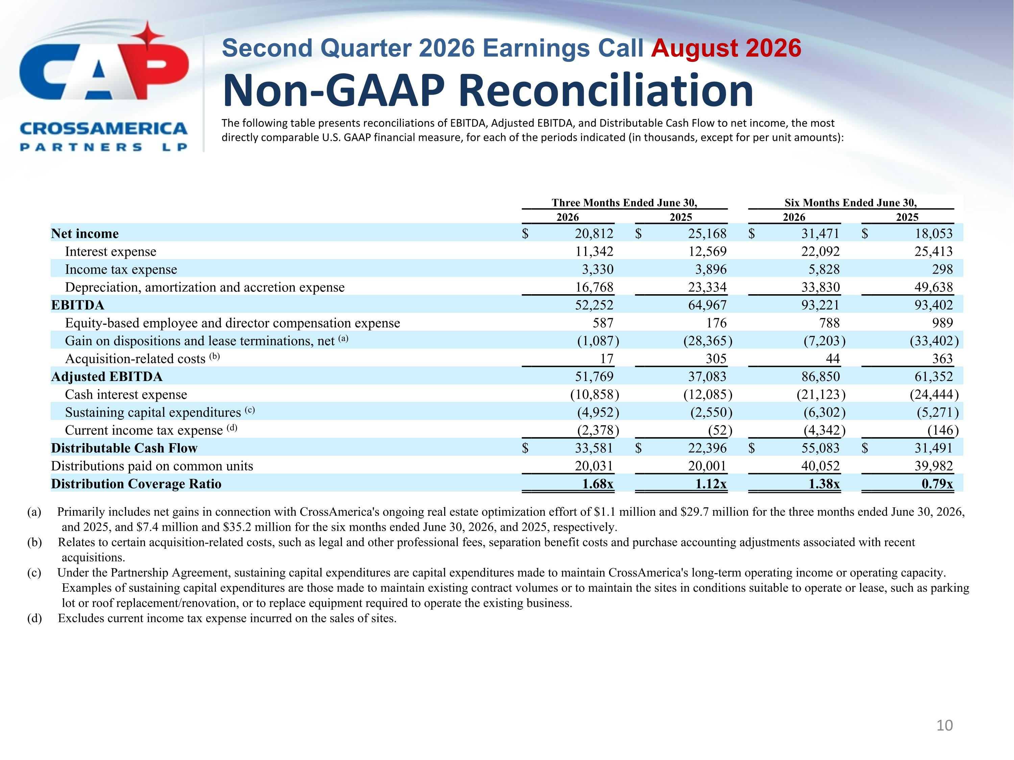
Non-GAAP Reconciliation The following table presents reconciliations of EBITDA, Adjusted EBITDA, and Distributable Cash Flow to net income, the most directly comparable U.S. GAAP financial measure, for each of the periods indicated (in thousands, except for per unit amounts): (a) Primarily includes net gains in connection with CrossAmerica's ongoing real estate optimization effort of $1.1 million and $29.7 million for the three months ended June 30, 2026, and 2025, and $7.4 million and $35.2 million for the six months ended June 30, 2026, and 2025, respectively. (b) Relates to certain acquisition-related costs, such as legal and other professional fees, separation benefit costs and purchase accounting adjustments associated with recent acquisitions. (c) Under the Partnership Agreement, sustaining capital expenditures are capital expenditures made to maintain CrossAmerica's long-term operating income or operating capacity. Examples of sustaining capital expenditures are those made to maintain existing contract volumes or to maintain the sites in conditions suitable to operate or lease, such as parking lot or roof replacement/renovation, or to replace equipment required to operate the existing business. (d) Excludes current income tax expense incurred on the sales of sites. Three Months Ended June 30, Six Months Ended June 30, 2026 2025 2026 2025 Net income $ 20,812 $ 25,168 $ 31,471 $ 18,053 Interest expense 11,342 12,569 22,092 25,413 Income tax expense 3,330 3,896 5,828 298 Depreciation, amortization and accretion expense 16,768 23,334 33,830 49,638 EBITDA 52,252 64,967 93,221 93,402 Equity-based employee and director compensation expense 587 176 788 989 Gain on dispositions and lease terminations, net (a) (1,087 ) (28,365 ) (7,203 ) (33,402 ) Acquisition-related costs (b) 17 305 44 363 Adjusted EBITDA 51,769 37,083 86,850 61,352 Cash interest expense (10,858 ) (12,085 ) (21,123 ) (24,444 ) Sustaining capital expenditures (c) (4,952 ) (2,550 ) (6,302 ) (5,271 ) Current income tax expense (d) (2,378 ) (52 ) (4,342 ) (146 ) Distributable Cash Flow $ 33,581 $ 22,396 $ 55,083 $ 31,491 Distributions paid on common units 20,031 20,001 40,052 39,982 Distribution Coverage Ratio 1.68x 1.12x 1.38x 0.79x

